

**Student : Raman Kumar**

**Student ID U2173241**

**University of Hudderfield**

**Dissertation**

***Title: ERP System For Institutes***

Table of Contents

Abstract 5

List of table and figure 6

Chapter 1: Introduction 7

Enterprise Resource Planning System (Background) 7

OPEN ERP (Python) 7

Knowledge Management in ERP System 8

Educational ERP system in the Market 8

Identification Analysis of Failure Attribute of ERP System 8

Implementation of Higher Studies ERP System 8

Technology Factors ERP systems and Organizations performance in Developing Countries 9

Common features of ERP software in Higher Education 9

Benefits of Higher Education ERP Systems 10

Key Considerations of ERP 10

ERP for Higher Education system 10

ERP Modules 11

Recruitment Management 12

Time Office Management 12

Payroll Management 12

Leave Loan and Arrears Management 12

Employee History 12

ERP software scalability 12

ERP Record Management 13

Student record 13

Faculty records 13

Teaching Progress on ERP solution 13

Success Factors for Higher Education ERP 13

Aims & Objective of Research Project 14

Project TimeLine 14

Metrics Based Analysis of Educational ERP Solution 15

Technology 15

Chapter # 2: Literature Review 16

Related Work 16

ERP System Functionality in Higher Academics 17

Higher Education Software Misfit 18

ERP System in Egypt in context of Educational processing 19

The Success Factor of ERP system in Higher Education in Saudi Arabia 19

ERP of Advance Developing Countries in Deeper Look 20

The Characteristics of Good ERP 20

Educational Enterprise Resource planning in Software Solution 20

Medium Sized Python library for infrequent Events 21

Open Source Idea on ERP 21

Python Recent Trends in Application 21

Studies on OpenERP 22

PostgreSQL 23

Features of PostgreSQL 23

Comparison of OPENERP vs SAP 23

Cloud ERP data processing practiced 23

Small and Medium Enterprises OPENERP ODOO 23

Software Metrics in Agile Software 24

Software as Service ERP system 24

OpenBravo ERP in Enterprise organization 24

Critical success factor in ERP 24

Managing Records in Enterprise Resource Planning 25

ERP implementation in various industries 25

The evaluation of enterprise source preparation using ISO 25010 created quality model 26

Usability Evaluation of ERP System comparison between SAP S/4 HANA and Cloud 26

Online ERP software 26

Customized ERP Software 26

Cloud Computing ERP 27

Business requirement 27

Success Element of Customized ERP solution 28

OPEN SOURCE ERP 29

DJANGO Framework based ERP for Institution 29

Implementation of Database using flask Framework 31

Python Flask Features 31

Conclusion of Literature Review 31

Chapter # 3 Methodology 32

Introduction 32

Research Philosophy 32

Research Strategy 32

Python Flask 32

ERP in Flask 32

Features of ERP Solution for Academics 33

MYSQL Database 33

HTML & CSS JavaScript 33

Flask Python Pages 33

Login Profile 33

Data Collection Method 34

Quantitative Method 34

Research Analysis Method 34

Fused or Unfused ERP II 34

ERP Utilization Experience in UK context 35

Quality Assurance in Higher Education 35

ERP Small and Medium Enterprises UK 35

ERP SWOT Analysis 35

Ethical Concern 36

Chapter #4: Result & Analysis 37

Result of Python ERP 37

1. Home Page 37

2. Register User page 39

3.Login PAGE 40

4.User Profile Page: 41

5.Logged out to get home page again 43

6. MYSQL Database 43

7.Database Records 45

8.Python ERP Project 45

9.Python Code Review 46

10.Python Packages 47

11. Critical Analysis 47

11.1 Sentiment Analysis 47

11.2 Enhancing Automation using python code Injection 48

11.3 Big Data ERP IOT Projection 48

11.4 Developing Module Generation for ODOO using Low code development platform 48

A roadmap for migration system architecture decision by Neutrosophic ANP Standard for ERP 48

Implementation of Container based Parallel system for automation software testing 49

Higher Education ERP Solution 49

Features of Higher Education ERP systems 49

Benefits of Higher Education ERP Systems 49

Manage Student information effectively 50

School Management System 51

Student information System 51

School administrative software ERP 51

Chapter # 5 Discussion & Conclusion 53

Comparative Discussion of Open Source ERP Software 53

TINY ERP (OPEN ERP) 53

SQL ledger 54

Automated Software Architecture Security Risk Analysis 54

OPEN SOURCE ERP to Support Chicken Meat Processing Company 54

Effective ERP Solution based on Case Studies 54

Recommendation & Solution 55

References 56

# Abstract

ERP solution OPEN source which only support manufacturing and industrial applications, so the predefined dataabase applicaiton which does not meet the exact educational requirement, in previous ERP solution which has various complexity and issues due to poor software planning of the system since Java, C# APS and C++ which does not support the ERP solution in organized way due to complex programming system, so python flask web based application works efficeintly and well to support MSc student program based on semester system, this ERP solution only deal with MSc program student of computer program.

Python flask is light weight micro web application which is fully integrated with MYSQL database system to store the sutdent login records in real time. Student logged into the system to view their educational resources such as assignment, and lecture notes, PDF lecture and Video lecture is main agenda solution to meet the research gap.

This reseach combines all modules functionality in one layer which support login based solution that contains all educational helping material, lecture slides etc. Faculty and student meeting time is also displayed on the top, hence regular class schedules is listed there.

Technical literature reivew has been conducted in comprehensive manner to reivew the research gap and issues, the idea is coming from literature to develop python application which has novel framework intregrated and managed easily on the top.

This research does not harm any human during research findings, so this reserach works is not part of any profit and funding agency. Its only support disseratation requirements of academics.

# List of table and figure

*Figure 1: (Saabith, A.S., Fareez, M.M.M. and Vinothraj, T., 2019) most wanted programming page 22*

Figure 2: data flow diagram of ERP Level 1 page 30

Figure 3: ERP System Flask App home page page 37

Figure 4: Python BOOTSTRAP HTML template page 38

Figure 5: User Sign in Login Page page 39

Figure 6: Registered user login page page 40

Figure 7: Complete ERP Registered User ERP page page 42

Figure 8: ERP Home Page after logged out page 43

Figure 9: PHPMYADMIN MYSQL database page 44

Figure 10: Database record page 45

Figure 11: python coding overview page 46

Figure 12: python packages in pycharm page 47

Figure 13: Architecture of OPEN ERP page 54

# Chapter 1: Introduction

Enterprise resource planning system control various educational resources , it encourages students to login to ERP portal to executes theri educationl resources. (Sun, G., Huang, Z. and Yue, L., 2022) this project going to develop the ERP system proposed on python Flask web application which complete with MYSQL server database for recording the student information. Flask is micro web framework of python which is better than DJANGO, it contains render templates to execute HTML and CSS files using the main root directory of python application.

This project using the advanced programming technique including user friendly management of resources such as login page, sing up page and home page. This project only focused on MSc computer science student which comprised of semester system. It facilitate the overall MSc degree program content composed of assignment, lecture notes, lecture slides, video lecture, lecture schedules and faculty meeting time which is designed according to the time period. However the educational resource management approach based on model selection which process the backend query on database server engine.

Hence teaching and learning material is major requirement to fulfill the research gap in the previous ERP system releases. Since the entire learning process design to facilitate the student requirements according to the given ERP condition. New student first signup to complete their registration process after it get the login id and password to proceeds the home page of ERP, in view of home page which get the latest assignments, Video lectures, slides and other material resources. This project design with Pycharm community 2022 edition including python latest library and MYSQL server. In the previous ERP releases student do not have open platform to execute the educational resources.

## Enterprise Resource Planning System (Background)

(Kendle, A.S., Nagare, et.al. 202) enterprise resource planning system encourage the institutes to manage their finance and fee related issues, online admission system process and student semester management system proceeds with web based portal which manage and organize various system in order to manage the educational resources. The proposed system is called educational management comprised of MSc student program. Python flask organizing render templates html & css files which focused on student data management system such as assignment, task, project, lecture notes etc. digital platform developed with MYSQL database system providing forum to student hiring process. (Sisyukov, A.N., Bondarev, V.K. and Yulmetova, O.S., 2020,) ERP data analysis including data visualization which process the high computing to integrate the educational resource in less time. Comparison of previous ERP system composed of Oracle, Java and C# ASP application which does not perform well due to high complexity of programming and database binding. ERP analytics performed using the SAP/HANA platform which carries data analytics to handle the complexities in different term.

## OPEN ERP (Python)

In previously open ERP project designed which provides solution open source management solution. Various business application has been managed by this project which contains necessary features and action in order to optimize and organize the different enterprise process.

1. Financial & Accounting
2. E-commerce
3. Sales and purchase management
4. HRM & Marketing

The research gap has been identified because educational OPEN ERP does not includes in this projection.

## Knowledge Management in ERP System

(Kumar, A. and Gupta, P.C., 2012) since ERP system manage & organized various educational resources system which adapted the advance technology hence implementation of ERP system to support colleges and Universities of UK which needs customized support to achieve the objective of educational resources. In previous releases of ERP software which does not perform better according to the educational needs and requirement. The implementation of real ERP resource planning system which includes various complex functionality that process the finance management with educational resource management. Various online educational resource management system available but the lack of business requirement which exist the major gap to manage the educational resources. Hence enterprise knowledge management system which organize the way of meeting to conduct online session to meet the student forums.

## Educational ERP system in the Market

(Kulkarni, A., Hegde, N., et.al., 2015.) ERP solution provides the solution to solve various complexity in one vision platform which designed according to the vision of faculty and student management purposes. Educational environments improves the overall condition of teaching and learning but student required online learning which composed of lecture slides, notes, video lecture. This research dealing the market competitive ERP solution which comprised of various educational management system hence the corresponding features would be part of dealing the student resource management. OPEN source online ERP solution does not provides the customized feature to manage educational requirement, so this forum is fail to deliver the complete vision.

## Identification Analysis of Failure Attribute of ERP System

(Kumar, A. and Gupta, P.C., 2012.) Rapid development of ERP system which needs higher studies guideline to design the solution which focused on higher studies student. The higher educational resources composed of undergraduate and graduate program, higher educational identified the required attributes which required by the higher studies student. This research studies the case studies of higher education system which dealing on different failure of ERP solution, ERP system easily crashed due to negligence in the programing.

## Implementation of Higher Studies ERP System

(Qian, L., Schmidt, E.K. and Scott, R.L., 2015) the framework of ERP solution in vision of higher student management hence higher educational institutes which adapt the business management solution. Enterprise resource planning system recommends the key factor of Purdue University which implements on SAP, hence the SAP solution which failure and crashed in lack of educational requirements and poor interface system. The ERP solution design to meet the internal departmental requirements such as administration department should meet the finance department via ERP system. The implementations of ERP solution designed with solution oriented to achieve the business goals.

## Technology Factors ERP systems and Organizations performance in Developing Countries

(Nadarajan, S., 2015) ERP software adapting by various organizations and technologies by deploying several factor analysis with the implementation of educational resources and educational factors, since the impact of educational institutes working over the planned activity by achieving different objectives of educational institutes and organizations objectives, since the conceptual framework works on the relationship between the attributes and entities resources by reviewing different software processes since the certain factor of common activities working on proposed framework in particular countries to achieves the objectives of business and profit relationship. Since there are various attributes and cardinalities based framework has been proposed and suggested in previous ERP software but the issue exists to achieve the certain task of business oriented approach which mitigating the several educational processes. Since the ERP software in previous contains different issues and challenges which does not working accurately as per the requirements of businesses and educational institutes, so various errors and issues exists in the execution of software modules, hence ERP provides solution that mitigate the educational resources, C# and Asp.net programming does not working perfectly due to Microsoft API complexities exists with open source software, beside this Java programming rapidly growing in those days because the required component to executes the enterprise resource planning tools which are software framework. Since the ERP software using the different technology and software factor to produce something better result, which are proposed on object and objectives of software development lifecycle.

## Common features of ERP software in Higher Education

1. Admission Management

ERP software eliminate the manual admission process which are based on basic files and folder system, since the common features of admission system are based on student academic documents and student information record keepings since the application processing and registration processing which are integrated on email and SMS functionality.

1. Attendance Management

Integrate student’s daily schedules and track of student attendance, creating student report and attendance which are managed through SMS and Email system alert system.

1. Tuition Fee Management

Creates multiple plans for different student courses, new student enrollment process manage and organized by ERP software such as multiple plans, track payments, generate receipts.

1. Alumni Management

Create, maintain and update alumni database the online creating which process on registration process.

1. Curriculum/course management

ERP software enable them to capture different payment and enrollment processes. Online curriculum and syllabus management which are dealing on different objectives.

1. Faculty Management

Manage and organize faculty management which process all faculty queries and task.

1. Student information / record systems

Create and maintained the detailed student profiles which are generates student id, with unique student id, name, address, and integrate student information system, since the student information system is used for record keeping purpose.

1. Academic Analytics

Student and faculty daily activities uploaded on ERP Moodle system which generates comprehensive reports on them.

1. Student Portal

Student enrollment, information management system, student registration process which are easy to use and comprehensive way to organize the student admission process.

1. Certification/Document Management System

Student and faculty management system which are organized by university staff which has been organized on the basis on auto approval, manual approval and certification rejections and document attestation system, hence student generated request on printed threads which achieved to manage different types of mitigations.

1. Inventory managements

Creates and managed the list of items such as books, stationary, computer equipment which are basis on computer hardware serial number and compute number, all necessary local area hardware equipment are designed on the basis of computer system.

## Benefits of Higher Education ERP Systems

Increase daily incentives and daily productivity to maintain and manage higher education ERP system which are accurately organized, since the ERP systems are implemented on several different resource allocation tools and elements, the data administration access and organize them which organize on the basis of campus and department integrated on different platform which are organized on different certain objects.

The system is able to connect multiple department of higher education system such as all educational schools are connected among themselves. School of computer, school of engineering, school of textile and fashion design, school of education, school of psychology, school of business , school of economics all department can communicate with among themselves, since the ERP system will facilitate them in more advance and robust manner to achieve the different goals and certainty and solves various complexity.

The effective internal communications are designed on different well-oiled machinery pattern, institution to institution communication and corresponding are possible through based on higher education institutes pattern which process and executed by ERP software.

## Key Considerations of ERP

Higher education would ensures that all the departmental implementations are scalable and reliable which adapted by higher education’s institutes are. Since the ERP implementations support several software vendors, the email and software configuration manage and organized by differ objectives of ERP institutions which are support them on different cardinality and attributes.

## ERP for Higher Education system

Enterprise resource planning software are designed on several objects which meet all the requirement of higher educational institutes, which powered by higher educational institutes that are used to manage all the necessary relationship objects of software planned to organize the software development lifecycle. The tedious task are organize through ERP software hence the implementations of processed data and information which are managed through the web based systems such as to manage exams, admission system and accounts system which required to process the necessary details. The processed information are organized through the ERP software which are necessary elements to produces the certain information and certain task. All schools financial and procurements system organized through the digital solution which necessary elements of educational institutes, digital solutions and all necessary educational elements are necessary to process all necessary solutions. Lighthouse ERP software is best choice integrated software tool which organized and managed all necessary educational components that are deal by different educational resources. Since the Lighthouse ERP software is one stop software solution which are designed and planned according to the given requirements of educational institutes. These all functionality:

1. Academic Management
2. Learning management
3. Apps and web portals
4. Finance
5. Payroll/ HR
6. Stores and procurement

## ERP Modules

There are several significant ERP elements which are composed of different educational elements to process business and industrial applications. ERP enterprise resource planning software which are backbone of any educational process management, since ERP software are designed on different objective models to process the object elements, hence the educational resources are planned and managed by ERP tool to organize the seamless communication process which are designed on across the department. Since ERP software support educational employees, staff, faculty, junior staff pay management system which are backend connected with banking system.

The ERP modules are on the following elements as follows:

1. Material management
2. Quality management
3. Logistics and movement
4. Sales, marketing and dispatch
5. Fiancé and accounts
6. Production planning

The key factors of ERP software are mapped and planned through on business oriented approach, which used to organize the software modules functionality.

Human resource management system are efficiently organized by ERP software, since the educational resource implementations are executed on the basis of software functionality modules. The human resource management system are enable them to capture the software modules functionality which are on the basis of software component to execute certain task of human resource and management system.

The human resource management system enable all internal resource allocations system that used to process the controlling of human resource management system applications. Maintaining employee attendance, timing, payroll, HR, training, appraisals progression which are based on simple tasks, the data and information are easily accessible through the human resource management system operational field. The tedious task are maintained through enterprise resource planning application which are used to maintain different educational resources, lighthouse software offers different types of object maintaining activities, since it’s are deigned to maintain the different objects. The powerful operations are associated with enterprise resource planning based solution which are maintained and updated through the system components. Since the special features are deal different kinds of employees featured product such as time and attendance, employee self-service, payroll, appraisals and progression.

## Recruitment Management

* Request for manpower and endorsement
* Taking of key data in prospects of resumes
* Request letter
* Staffing procedure on the basis of manifold boards and levels
* Proposal letter
* Selection letter

## Time Office Management

1. Data and information acquisition from attendance car reader / on biometric system
2. Physical feeding of attendance which are import from excel sheet
3. Overtime management
4. Shift planning and rooster
5. Revised shift planning considering the leaves and tour details.

## Payroll Management

* Muster roll attendance breakup in fourteen parts
* Salary generation for month wise and days wise
* Employees performance incentive managements
* Reimbursement and claims
* Income tax and claims
* Income tax calculations and management

## Leave Loan and Arrears Management

1. Leave application, approval with leave encashment
2. Arrears are calculated on auto generated systematic computation approach
3. Employees Loan application management with deduction instruction
4. Loan update history according to salary deduction management

## Employee History

Employee documents and academic certificates are scanned and managed in ERP software.

## ERP software scalability

Enterprise resource planning software needs scalable and organized robust approach to handle different educational resources to meet the different organizational mitigation process. Since the higher educational resource planning enable them to handle different objectives which needs to maintain the student and faculty record. Student should require energetic report based on their assignments and projects on weekly and monthly basis, additionally the ERP software would be able to handle different objectives with organized and scalable approach. It has noted that the enterprise resource planning software needs scalable and robust approach to answer the student and faculty query in real time. Database backend approach would enable them to higher the systematic approach in which several mitigation has been handled and organized.

### ERP Record Management

Student and faculty records should be managed in one table format, each student needs to query their records to approach the different segmented approach to organize the database management system. Since the ERP software would be used to educational purposes in which different departmental records has been organized and managed. Educational resources enable them to answer the query in which several educational departments resources has been executed.

### Student record

Student record is based on the following objectives:

1. Student assignment record
2. Student exams and project record
3. Student quiz record
4. Student thesis record
5. Student annual progress report

### Faculty records

1. Faculty weekly teaching progress report related to syllabus query
2. Faculty monthly teaching progress report related to syllabus query
3. Faculty exams progress query
4. Faculty paper marking and testing query
5. Faculty maintain student records in daily basis

### Teaching Progress on ERP solution

Since the ERP software based on enterprise resource planning in which several enterprise query has been resolved, it has been noted that the teaching progress has been maintained on priority basis in which the university target has been achieved. Professor should maintained their syllabus teaching records on ERP software and plan to mapped the teaching query in order to maintained the teaching objectives, since the professor marks student project, assignments and exams and updated each student report on priority. It has been noted that the student would enable them to achieve the systematic approach in order to maintain the teaching objectives, syllabus progress updated on priority in which the different teaching fellows query has been maintained them. Since the modern ERP software is based on modern online database storing system which stores teaching records on online database system, it has been noted that the each professor answer the student query instantly by deploying the online system. The target and assigned teaching objectives has been achieved in which the teaching and learning objectives has been achieved on the following parameter to answer the query. Educational enterprise resource planning system enable them to captures the systematic and organized approach to maintain the teaching progress on priority.

## Success Factors for Higher Education ERP

(Bologa, R., Bologa, A.R. and Sabau, G., 2009,) success factors of higher education system implementation of correct ERP system which meets the educational requirement. Since the critical success factor of educational ERP system designed with customize solution which identify the project outcomes. Since the project management of ERP solution planning according to the business and student requirement. Previous releases of ERP solution which was crash and fail due to poor planning of interface and poor planning of resource management system.

## Aims & Objective of Research Project

Aims of this research project to develop ERP solution composed of Flask web framework and objective achieved on the following parameter:

* By developing python flask web framework composed of render html template which designed on MYSQL database platform to record the student profile.
* Deploying the Bootstrap web application framework to design student signup and sing in page which essential elements of every ERP to manage the user session.
* Conduct critical literature review composed of latest ERP solution.
* Develop Flask Solution to achieve the MSc student studies content in order to achieve the project timeline.
* Develop lecture and studies material based student profile which designed on single user login platform which meet all the business and educational requirements.

## Project TimeLine

Gantt chart design to develop the python flask web application framework which meet the higher studies requirement as follows:

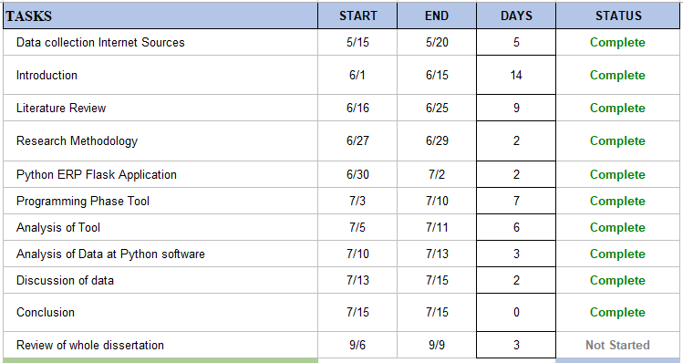

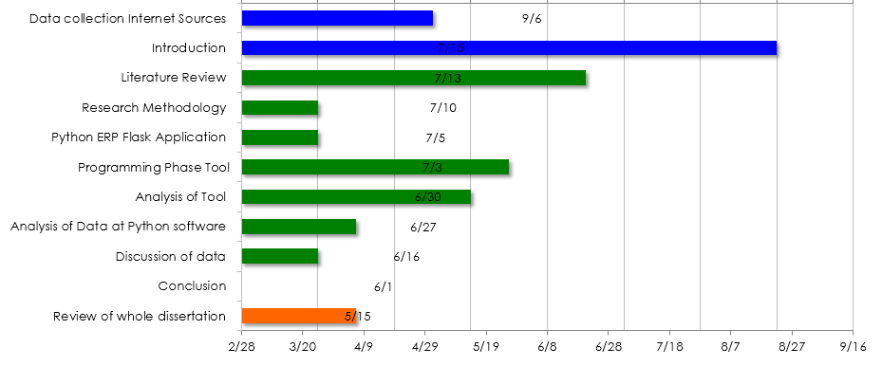

The project timeline make attention with supervision of project supervisor which deal all the necessary actions taken to complete the project on the given time period.

## Metrics Based Analysis of Educational ERP Solution

The metric based ERP solution analysis has been made by using the fuzzy logic AI system which developed to meet the entire finance and administration requirement. Since fuzzy logic system is branch of mathematics computing which build the real world model in way of meet the critical requirement. Since the implementation of testing ERP solution by meeting the view of ERP solution which mean to evaluate and identify the student and business requirement. The performance and metric evaluation which identify the failure and success factor of recent ERP solution. The current projection designing are composed of Python Flaks ERP solution which meet all the necessary requirement. The studies and lecture material which are major elements of every ERP solution success hence the combination of assignment and assignment task solution which fulfill the research gap by deploying this comprehensive and easiest application using the python flask framework.

## Technology

Python programing is major programming tool which are one of the best reasoning to choose because its light weight and easy to develop including MYSQL database application. The design and implementation of ERP solution which mean to deploy the MSc student studies program, only focused to design the studies and teaching related queries. The student query related to assignments which are revised regularly on the basis of student requirement because requirement has been change on daily basis. Class schedules and assignment uploading schedules are mandatory part of this project success. The success goal of this project are laid down on the following parameter of technology as follows:

1. Python Pycharm Community
2. Python Flask tool
3. MYSQL database engine
4. Bootstrap templates (HTML &CSS)

# Chapter # 2: Literature Review

Investigation of previsous studies which composed of ERP solution, the research finding based on experiment and test the previous reserach on ERP system, since the ERP system of educational support whihc does not support fully supported component of an educational needs entity. So this research fulfill the gap in between the exact educational requirement on basic needs to top level requirement which fully functional to support student requirment.

## Related Work

(Soliman, M. and Karia, N., 2016) in Egyptian higher educational institutes ERP system implementation which necessary requirement of educational need, since enterprise resource planning manage student query, organized fee system, manage student programs and faculty issues. ERP system improves efficiency and enhance educational operations with assistance administrative of education institute. Since it has been investigated that ERP system able to did all educational operation in one platform either faculty query, student query operation and administrative feedback with assistance of educational schools, since the every educational school have their own requirement, so the requirement is different and all operational efficiency has different from one another. (Abugabah, A. and Sanzogni, L., 2010) enterprise resource planning system to executes all operational of education institutes since it was not functional well due to lack of business requirement and educational requirement, aim of this research to explore the issues in the previous ERP system, since this research focused in educational system in Australia, hence ERP particular references with user interface to process complex query and operate different module, this research investigating only literature finding based solution. (Allen, D., Kern, T. and Havenhand, M., 2002) ERP critical success factors this research exploring contextual factor composed of public sector educational institutes. Implementation of advance ERP needs remove duplicate resource which recover educational procedure hence educational ERP using the complex structure of enterprise resource planning based solution, higher educational institutes facing lack of requirement which causes issues and challenges to process the query. The public sector universities requirement has been increased on day to day business functionality. Since ERP system utilize various operations which needs improved functionality on the basis of system requirement. Since the critical success factor of ERP system established with changing the software requirement functionality in response of faculty and student requirement various package of ERP has been investigated in this research in processing of complex management operation need. (Pollock, N. and Cornford, J., 2004) additional ERP system is unique requirement of educational need. ERP system widely used in large scale organization in entire world, hence ERP system used as replacing of existing management and administration computer system. The generic function of ERP system to process management related task and update database on day to day operation need. ERP system in UK in various institute to implement educational resource planning in extent in which higher educational institutes are organized and managed in view of processing large complex query operation. The distribution of ERP system implemented in view of resource planning and educational needs to process large query processing to process large query operation at entire educational level. ERP software designed according to the suit of university education program various educational program, hence the ERP software in view of processing of large query processing operation. (Klaus, H., Rosemann, M. and Gable, G.G., 2000) ERP system (enterprise resource planning) in information management system to practically literature review has been investigated in this research to explore various ERP based, since ERP analysis has been investigated proposed on historical analysis, meta-analysis in survey of academic research. ERP system achieved based on commercial training community. Since in UK academic ERP system is also used for teaching material to use as aid for assisting the educational requirement. ERP software deployed for teaching and training purposes to achieve the certain task on particular way, ERP system aligned to manage and organized with certain query processing of educational institutional, augmented slide role in concept of ERP management solution in IS which beneficial for entire educational industry. (Surendro, K. and Olivia, O., 2016) academic cloud ERP quality assessment hence the educational institutes which was composed of conventional academic ERP system which integrate and optimize in business processing. The distribution perfect are installed and managed on the basis of entire business modeling. Educational institutes installed and maintained on the basis of ERP planning software in functional of departmental management operation. Institutes might be able to process complex query operation on the needs of educational resource management. This research suggest cloud based ERP solution which are based on software as service in ERP system modeling. ERP system is virtualized technology to execute in cloud computing server platform since amazon, IBM, ORACLE is one such examples of cloud ERP solution but are very expensive with their business requirement. ERP solution integrate and managed on the different perspective of ERP solution, the objective of cloud ERP solution to facilitate the entire educational functionality which are based of administration process, admission process, student curriculum management faculty management, faculty teaching management and at the end of every month cloud ERP generates student fee receipt automatically and send them on particular email address. The implementation of ERP system executes on specific rules. The implementation of ERP cloud system using the virtual operation system in processing of admission and student enrollment. Since cloud computing ERP system works very efficiently but the monthly and annual package was very expensive, might be the public sector universities unable to deploy expensive packages, cloud computing architecture constructed on software as service, platform as service, database as service, email as service, etc. since the attribute of cloud architecture consistently works on processing of large query operation in respect of entire educational planning.

## ERP System Functionality in Higher Academics

(Noaman, A.Y. and Ahmed, F.F., 2015.) Enterprise resource planning software considering one of the best software solution to manage and organized the entire educational process. Since the educational enterprise resource planning software that process the large business operations, the higher educational operates on certain complexity by achieving the good academic score by other academic institutional, since the ERP system implementation process on different modules which should be responsible on real requirement of educational need, since the version of legacy system in entire ERP system in higher education which are go through the complex query operation in view of certain admission task, examination task, student enrollment task the one such experience of ERP is student admission process and enrolment processing system was very complex, it was investigated that student enrollment processing achieved by online system which accepts student previous academic records, and accept the document on the criteria of database management system and automatically generate report one such fee voucher of student and other expenses, beside this electronic commerce attached in this framework. This paper present the successful implementation of enterprise resource planning at educational institute level, it has been observed that ERP system is software module which are composed of various software modules functionality which support multiple business operation. Since ERP control industry operation, finance operation, business operation, it has also used for predicting inventory of stock, calculation of certain finance related query, ERP software works as educational own software, but confidentiality integrity, security which was one such major requirement to secure the end to end data sending and receiving operation. In previous ERP system which process only student registration query processing on the basis of financial management, procurement management and administration management operation only, but the research gap has been identified that the ERP is major requirement of processing the teaching material for faculty, student lecture material, student examination management and processing of grades and the end of every term.

## Higher Education Software Misfit

Since the educational institute missing their educational requirement and student management requirement, so it was investigated that various studies presented the research gap in between the processing of certain query operation of student enrollment processing, student fee management, student grade management, and ERP software does act like on the basis of functional and nonfunctional requirement of the education. Since the ERP solution does not meet the exact the requirement of the educational system, previously in 2005 the ERP software does not support fully functionality to process complex query operation, with lack of educational requirement, high turnover rate in the educational industry to project the team member. EPR lifecycle implemented on ERP knowledge which process on the certain given task. So there are the list in which the ERP does not originate awake with the following educational need.

1. Unfortunate IT arrangement
2. Unfortunate knowledge transfer
3. Unfortunate customization of ERP tool
4. Poor top management support
5. Poor IT management support
6. Poor project schedules
7. Poor management of ERP business solution
8. Poor student management processing
9. Poor query processing
10. Poor interface with slow speed in query processing

Since it was investigated that ERP solution executes on certain type of server computer which contains operating system, since the ERP system executes on windows operating system in previous Microsoft releases the poor functionality of windows operating system in window 7 and window 8 operating system which does not perform well according to the given requirement of the education. Since the Microsoft server operating system performing well, one such window server computer contains with enterprise services quality with enterprise resource planning file system which process large and enterprise file system rapidly. ERP software comparison modules on the basis of their vendor has been investigated from the literature.

|  |  |  |  |
| --- | --- | --- | --- |
| SAP | Oracle | PEOPLESOFT | JD Edwards |
| Sales & distribution | Marketing and sales | Supply chain | Order management |
| Material management | Procurement | Customer supplier relationship | Inventory procurement |
| Production planning MRPII | Manufacturing | Manufacturing | Manufacturing |
| Quality management | Educational | Enterprise | Industry management |
| Plant management | Service management | Human resource management | Workforce management |
| Financial accounting | Financials | Financial management solution | Time and expert management |
| Asset management | Asset management | Enterprise asset management | Project management |
| Workforce management | Order management | Contact management | Sales management |

## ERP System in Egypt in context of Educational processing

(Soliman, M. and Karia, N., 2015) in all globe ERP system improved their functionality and processing system the target of selecting the good ERP vendor which was very difficult to answer that since the educational processing which has been updated their published material, in Egyptian universities ERP system works like the given requirement of the education, it does act like the given certain query which has asked by the user and administrator to process the certain complexity of the system, since the complex query processing of ERP system composed of different parameter in which the given requirement of the educational system which are straight forward to meet the certain task which exact meet the student requirement as well as meet the administration requirement as well. The ERP system functionality has been processed and organized on the basis of complexity of query processing. Since the enterprise resource planning system organized the certain query processing operation on the basis of merged solution oriented system to adopt the primary and secondary requirement of admission processing and student enrollment processing which exactly meet the student criteria on the basis of admission process. Since it has investigated that the ERP system was facing critical issues by student admission processing system because various student processing system has been investigated and suggested with different solution to process the business requirement. Since the ERP system in the past used for manufacturing process and distribution sales processing only, beside this ERP solution used as financial assistance tool to generate inventory control receipt, bill, receipt etc. employees salary management, employees job history management, since the ERP solution is only part of human resource department for record keeping of employees database, but with the passage of time the ERP solution works efficiently with organized task. Since ERP system in multiple education system which process information management system, student administration management processing system.

## The Success Factor of ERP system in Higher Education in Saudi Arabia

(Aldayel, A.I., Aldayel, M.S. and Al-Mudimigh, A.S., 2011) since the ERP is essential tool to managing and processing of student and faculty task, beside this ERP solution part of administration, accounts and finance department ERP control and manage by the IT department of the university with assistance of IT manager of the university, since ERP is works like manager of the system which produces certain report on given period of time. This research investigate and explore various research studies which part of Saudi Arabia education. Since the implementation of ERP system which are looking for certain improved task to solve the various complexity the critical and success factor of ERP solution which identify the certain query operation on the particular time period of business logic. Since ERP connected on backend database system and data warehouse system which mine the information and process the large data to produce data analytics like framework, the advance ERP system control all educational operation such as teaching operation, student control operation, all university operation has been set back on the front of ERP interface. Since the successful implementation of ERP system classify on the given time period to operate and investigate the different modules, this research investigate the case studies of King Saud university at Riyadh Saudi Arabia. Since the project management of ERP system based on critical factor of ERP system which required by different software modules.

## ERP of Advance Developing Countries in Deeper Look

(Abdellatif, H.J., 2014) this research investigating various ERP based solution which are proposed on advance countries , educational institute process their education query on oracle based solution. Since the recommended Oracle based solution which investigated on different complexity of the software module. It has been suggested that the ERP system is beneficial for all the academics of the world, ERP replacing the legacy system which lack the administration process and management process of the entire academics. Since from day one the ERP implementation was very risky and challenging due to the changing business requirement on daily basis. So there are two factor of ERP solution one such as failure either success if the business requirement does not reflect on the current situation of the software system which enables them to process the certain query processing operation on the given time period. ERP system in the past was very slow and data storing and data processing task taken huge time and reflect the business time and requirement, so the major issues has been highlighted that the slow processing and slow storing system since ERP contains in one such windows operation system the Microsoft windows functionality does not meet the enterprise file system, parallel file processing which has part of enterprise business which reach to entire medium of business requirement.

### The Characteristics of Good ERP

The following good characteristics are composed of good software functionality and the given requirement of the enterprise module. ERP system is open source tool which bending in all operating system such as windows, android, apple, sun, oracle, etc. since the ERP requirement engineering are deeply focused on software engineering requirement in which the certain given task operate and executes on the certainty of given requirement of business. ERP software solution designed on looking the two parameters such as customized design and built in design. The customized solution works very well. Since the ERP composed of standardized data definition function, flexibility which are based on changing requirement on day to day operation education requirements are changing and reflected on daily basis. Since ERP system run across the border nation development in which the overall system has been designed. Common access of software functionality on single access of data point, all the business operation processing has been executes on the given requirement of the organization. The simulation process of business requirement which is capable of simulating the reality on the basis of educational needs, the common functionality of ERP support executes on different regions, to organized different organization process. ERP is not limited because of various financial task and operational task has been performed by the ERP solution. Since ORACLE software functionality works well but the interface module of ORACLE does not perform better, the lack of software requirement. ERP system in higher education in developing countries to process various certain large complexity of database management system.

## Educational Enterprise Resource planning in Software Solution

(BE, D., 2021) traditional educational institutes works on the parameter of software functionality, the software parameter does like a manager in the education module, the educational programs and complex certain student program query has been processed and performed according to the given requirement of system. Since the ERP educational requirement are composed on the parameter of staff management, faculty management, administration management, schools management on the basis of different education programs. Since the school dean works actively participate in the development of good ERP solution, hence the requirement gathering another very complex task to process the educational program in the software. Each modules contain on business logic layer and database layer which centrally integrated with the front end layer. Software binding works on tight coupling to solve the complexity by software engineer modules, the parameter of agile development in the software development works well compare to waterfall model of software. Since the large association of student community including faculty all their functionality and modules are integrated with the single software layer. This research introduced the SAP software functionality, normally the SAP software works on processing the business related queries on the given time period. The principle components of different department and different education schools works actively on the basis of SAP tool functionality since the SAP tool enable to process the student query separately and faculty query separately. Since SAP contains low level compatibility which process college level support so universities required enterprise level support to organized and manage all universities functionality. Since the faculty and student management organized with the good functionality module on the basis of single logic layer of business class. There is need to investigate more in depth to find out the exact enterprise tool which process all enterprise query.

## Medium Sized Python library for infrequent Events

(Lervik, A., Riccardi, E. and van Erp, T.S., 2017) transition path sampling for rare event studies, transition exchange random sampling and replica exchange transition sampling (Python, G., Fargier, R. and Laganaro, M., 2018) ERP for different procedure semantic and daily events for classification method to achieve the certain goal of enterprise development which enhance the communication capabilities. The blocked cycling naming paradigm library which produces the latency interface in context of event related potential for event recycling in heterogeneous events. Since python library still in under processing which enhance the development interface of communications.

## Open Source Idea on ERP

(Ganesh, A., Shanil, K.N., Sunitha, C. and Midhundas, A.M., 2016) enterprise resource planning used in across organization irrespective the scope of organization. Hence ERP used to process complex data query and making rapidly decision making query and generate business with effective parameter since the advance ERP trends has changed the communication situation with effective development of programing based solution using the ERP software by looking into the deep matter of system programing. OPENERP is one of essential ERP solution system for the educational institutes and organization. OPENERP ODOO is one of the richest source of ERP solution provider which enhance the business capabilities, OPENERO ODOO which offers organization no more pain on CRM integrations. ERP is new dimension with new advanced features of simulator based tool which guides the user how to interact with the software and system. Since OPENERP odoo developed in PostgreSQL and python programing which enhance the featured application visibility.

## Python Recent Trends in Application

(Saabith, A.S., Fareez, M.M.M. and Vinothraj, T., 2019) python is open source programing interpreted language used for everyone, simple, clear including object oriented features which enhance the programing modules visibility. Since python programing enable the system to activate the web framework, comparative to java, C++, JavaScript, and any other programing language which change the parameter and features of programing interface. There are lot of featured application already part of python programming, python is widely used for artificial intelligence application, machine learning, deep learning, data science.

1. Python Application for GUI web based including desktop featured.
2. Python application for image processing
3. Python application in graphic designing
4. Python application in scientific and computational
5. Python application in game development including 3D games development
6. Python application for software development
7. Python programming Rich application in business development
8. Python programing in language development

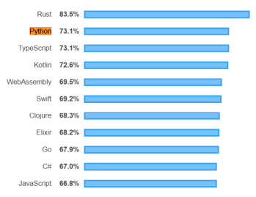

*Figure 1: (Saabith, A.S., Fareez, M.M.M. and Vinothraj, T., 2019) most wanted programming*

## Studies on OpenERP

(Jindal, N. and Dhindsa, K.S., 2013) ERP enterprise resource planning software extremely complex and very difficult to implement by using some programing interfaces, since Oracle, Java, SQL does not support fully functioned features by mean of good framework functionality. Since ERP software is largest which are capable of operate all organization functionality which all in all platform in one interface. OPENERP is modern design of ERP solution which are open source tool which is available for all operating system, desktop, apple, window, android, etc. the ERP enterprise management software written in python language which are modules based scalable intitutable with enhance capabilities of framework like structure. Since open source ERP software no cost required with no license which does not need expensive equipment. OPEN source ERP solution which are not customizable, it only works on pre-built in specific parameter to run and executes certain task. Moreover the ERP solution which are compatible for various industries and organization that means a lot for the entire industries which are capable and benefits for the entire community of world.

## PostgreSQL

PostgreSQL is relational database system which developed by university of California, since its very advance database system which offers all database functionality modules interface. It support SQL 2003 database featured like support since it was investigated in various researches that PostgreSQL is secure and stable database application which enhance the featured services and implementation features of system application and entire web based framework application, since this database support 6TB of database implementation.

### Features of PostgreSQL

1. PostgreSQL using the stored procedure which might be written in 12 programing language, it has highly integrated database works efficiently with python programing by using the psycopg2 component, since sycopg2 is known as PostgreSQL database adapter for python programing language.
2. PostgreSQL has sole database featured with good integration of programming module, the database binding with python programing structure fix the system which enable the system modules feature like functions.

## Comparison of OPENERP vs SAP

OPENERP is solution of all business application which used by various businesses to run their business application in all aspects, since OPENERP meet all the requirement of basic ERP of all business nature functions, beside this SAP is German software incorporate with multinational companies to generate business application and meet all the functionality of business development and growth. SAP is specifically works to executes business application only which does not part of any ERP like software. Since oracle is complex in development which does not integrated easily to programming functionality modules. Python works better to build effective application of enterprise resource planning which enrich with all database modules functionality which required by the system and educational institute.

## Cloud ERP data processing practiced

(Gao, L., 2020) since cloud ERP system essentially widespread, still various organization not yet migrate to cloud because data security breaches, various organization interested to being part of cloud ERP database system but with some other aspect of business application which does not related to secure concern and privacy. Since organization interested to investigate the data processing system on cloud based ERP system, this research investigate with case studies based cloud system method which enable the system to integrate with data processing agreement. Since the data preprocessing method and data integrity with confidence processing which enable the system to integrate them in advance confidence to build the major instances of business application requirement.

## Small and Medium Enterprises OPENERP ODOO

(Devkota, A., 2016.) The research gap has been investigated by exploring various researches articles, python individual application needs to develop to support educational enterprise resource planning, because python is fast, easy, integrated, open source, available for all operating system including all functionality and all aspects with good features. This research present the guidebook for the small and medium enterprise which using OPENERP ODOO to control and manage their business needs. Since it has been observed that small and medium enterprises using the following module as follows:

1. Managing accounting
2. Sales
3. Inventory control
4. Manufacturing
5. Customer relationship management

Since all businesses using this open source ODOO software which enhance the business capabilities. Beside this ORACLE and SAP too used already by various business which enhance their business growth. Since the recent ERP market is dignified with various low cost ERP system which fails to bring the high end result. Since the poor documentation and poor implementation of ERP tool which does not bring the good ERP solution, it was highlighted in previous researches that ERP system fail after some period of time.

## Software Metrics in Agile Software

(Destefanis, G., Counsell, S., Concas, G. and Tonelli, R., 2014) this research investigated eight object oriented system in which five of them using the agile methodologies three system design in python and five system design in java programing, hence the software compatibility metric has been generated to investigate the true meaning of software development by nature and their usages. Since the software method are compare with non-agile and agile development and generate progress metrics which highlight the software issues and challenges, since the agile system does not offer distributed support in the software strategy driven technique.

## Software as Service ERP system

(Abbas, A.A., Abdel Mahmoud, A.A. and Abdallah, M.M., 2015) since the ERP system was used only to facilitate the HR module, accounting module, project management module these three modules works separately, since the modules needs customer level database functionality support which used stored procedures method to subscribed. Since profile page used for user data input driven approach which stored in database, various user subscribed for individual module which needs accounting, sales and project related query. The full integrated supported which developed in python programing which support all functionality of ERP related query and method. The software as service modules deliver the subscription based method which only deal with the required user which needs ERP facilities. Additionally Java was best application in 2015 for creating effective web based ERP application.

## OpenBravo ERP in Enterprise organization

(Christianto, M.J., 2022.) ERP system OPENBRAVO works like OPENERP ODOO, both are working online ERP solution, which deal to support business community, hence OPENBRAVO ERP deal with retail business chain including restaurant and hotel business, hence its part of Spanish cloud based software solution. Since enterprise resource planning software support various organization in which plan their business according to the nature of the business, educational requirement are different from hotel, restaurant and business, since educational ERP only deal to support student level support and administrator level support including admission procedure. OPENBRAVO is ERP solution which is executable in web browser. OPENBRAVO contains general master level settings which deal with view production, inventory, customer, order tracking and workflow of information. Comparative to educational resources which needs to track student performance, faculty teaching material, student enrollment procedure, etc.

## Critical success factor in ERP

(AlQashami, A. and Heba, M., 2015) in these days information technology enable them to make useful software and tools which are most common demands of every educational institutes, meanwhile enterprise resource planning system needs improvement in every aspects and every domains to improve the data services. Artificial intelligence tools techniques enable them to capture the problem resolving them by detection prediction of machine learning enable tools. Critical success factor of enterprise resource planning should be based on all educational requirements. Enterprise resource planning software tools very difficult to design in the past so the advance development projection to deploy educational tool because ERP demand has been changed frequently. Software requirement analysis demands has changed frequently because software domains knowledge depends on different frameworks since it has been noted that the software development organized according to the needs of software path planning. Critical success factor of software development designing according to the nature of software design documents which deeply depends on UML. Object oriented software paradigm critically analyzed, predicted which would be better experience to analyze the software frequency. Since the enterprise resource planning designing which enable them to identify the educational resource allocations which demands by the student community. Higher educational institutes demands frequently changed due to educational syllabus changed in more depth which review them in every year, so needs to change in software for assurance of good software.

## Managing Records in Enterprise Resource Planning

(Katuu, S., 2021,) ERP system increasing demands of every education in the development of business which improves the student learning facts in more organized manner. ERP particularly used for planning of educational content, business solutions, students and faculty management. Integration task identify the educational resource according to the requirements of integrated task. The managing and integration process to organize ERP solution based on the expected outcomes of organized system. The implementation of resource planning which meets the educational requirements hence the development and assessment in making the educational content. Higher educational content focused on undergraduate and graduate level which prepared to meet all student educational requirements such as assignments content, lecture notes, PDF notes, and educational resource has allocated which enable them to captures the systematic reviews on higher studies. Subsequently the implementation of higher studies planning should meet the software requirements, educational contents planned according to the business requirements. The objectives of this research which focused on various factors which meet the educational resource planning, it should be considered when the student satisfaction exists in both organized manner.

## ERP implementation in various industries

(A. and Buddala, R., 2021) ERP system integrates all necessary action to complete business requirements like purchasing, sales, product planning. The businesses has diverse nature to invest in different business lifecycle ERP software provides the facilities in which the wide range of applications needs to executes the business flow. ERP commercial software available free of cost but there is needs to fulfill the research gap in between open source software and customize software. The ERP selecting process which organized various factor to smooth the operation hence the selected ERP processes adapted in more convergent manner. ERP is works effectively to organizing industrial projects, manufacturing process, there is problem in higher educational institutes in which the requirement has frequent change. Enterprise resource planning in educational institute review software requirements the needs of improved version of software development might be change on different time period.

## The evaluation of enterprise source preparation using ISO 25010 created quality model

(Islam, M., Imran, R. and Hosain, S., 2021) software quality standards deploy on fundamental nature of businesses, the evaluation framework of educational resource planning organized in different process. The software quality standards assures by ISO organization which focused on 25010 package. The evaluation framework predicted and analyzed on 50 respondent to validate the result. The respondent method tested validated which adapted the application layer approach which focused on assessment framework. This research suggest ERP solution by following the ISO 25010 standard in which to organized and stable the software solution.

## Usability Evaluation of ERP System comparison between SAP S/4 HANA and Cloud

(Soliman, K.O.S., 2021) the competitive results obtain through globalized market solution hence organization would meet the software requirements. The ERP solution would not meet the organization software requirements hence the interface is complicated to design the software quality that meet the business needs, the organization challenged on deprived quality requirement. The experiment result examining the various factor which focused on different software production, deployed software requirements which enable them to capture the software solution hence the great benefits of software development which deployed the great benefits to organize the software solution framework.

## Online ERP software

Several online enterprise resource planning software available in order to maintain the higher educational records, particularly in student enrollment process and student admission process, but the issues exists by maintaining and matching the university and student requirements. Online enterprise resource planning software based on enterprise solution the software factor based on enterprise solution framework in which different higher educational solution has been maintained and updated. Enterprises solution maintained and organized which does not work according to the higher educational institutes requirement, so online ERP software does not perfectly working due to incomplete requirement of enterprises software. Online software organized and managed through the Google internet API, since the internet API might not be able to work perfectly, since the enterprise resource planning software organized managed through the systematic approach of online system. Online software which are not works perfectly due to standard software system, the software has been classified and managed by the software usability to enhance the educational requirements, since it has been observed that the online enterprise resource planning software does not able to works according to the higher education system requirements, so it has been suggested by various researcher and scientist that customized software solution is best method to engage the educational resources.

## Customized ERP Software

Customize enterprise software based on organization requirement in which all necessary information has been recorded and listed, hence the database does not works according to the given query which requested by the client, the customized software organized and managed through the different object notation based lifecycle. The software solution is necessary element to handle the physical approach in which several enterprise software has been organized and managed. Higher educational might be able to buy the cloud computing resource planning but it cost, several higher institutes might be able to buy the online database storing package, enterprise resource planning software has been maintained and managed through the systematic approach of resource planning. Cloud computing system is designed by Amazon Cloud, Azure, Oracle, Open source, since the enterprise solution works on customized software planning in order to maintain the higher studies requirements, educational resource planned and maintained through the cloud computing environment which are not customized to manage the software solution of cloud computing environment.

## Cloud Computing ERP

Cloud computing system support several higher education system requirements which are composed of enterprise solution system, since the cloud computing environment is very costly which most of the academics does not afford costly package, cloud computing system works on object data which are composed of classified approach. Cloud computing system which required several features to executes them, but the issues and challenges are exists to meet the educational requirement. Cloud computing works on virtualization pattern, several issues and challenges exist to handle the virtualization processes, since the cloud computing on the demand server computing charge extra cost amount which are working on demand frequency of client attributes, since the cloud computing storage and email requirements featured on heavy cost requirement which enable them to capture the real implementations of higher studies, the higher institute change their educational requirements which are based on student and teaching objects in order to maintain the cloud computing environment. Since the virtualization process has been handled and maintained through the online web based system in which several hacking attack might be able to interrupt the cloud computing file system.

Cloud computing environment working on educational resources to meet the several issues and challenges, cloud computing which are able to reflect the educational resources which are maintained and organized by enterprise resource planning system.

Software requirement has been changed on daily basis due to change in resource management and reflects exists in educational requirement the required features are able to enable the higher studies resource planning which effectively works on resource planning parameter. Cloud computing interface works on region to region based which are featured on different objectives, same the cloud environments are regional based requirement which are featured on business solution to handle the entire business community. Since the cloud computing works on object to object notation based working which are effectively works on organized parameter to organize the business flow, market flow, organization flow, finance flow, employee flow.

Cloud computing effectively works on to support organization which are works on employees and client based requirement which has been featured on several business processes, since the business processes has been organized which are organized on the based on systematic approach.

## Business requirement

ERP software solution has been organized on several business requirements which are enable them to capture the systematic approach to meet the business requirements. All educational resources has been maintained and organized by the business solution which are necessary component of business solution, educational resourced has been organized and managed by enterprise resource planning software such as different software solution has been used to organize through the objectives which enable them to capture the working flow parameter which enhance the business flow.

Business requirement such as financial and asset requirement are managed through the online software solution. The software solution has been managed through the advance feature of software solution. The recent approach of business entitle which maintained through the business lifecycle, since the operation requirement would prefer to enhance the business lifecycle.

Since the business requirements are list as follows:

1. Fee and student voucher maintained in ERP solution
2. Educational resources maintained through the ERP solution
3. Department to department internal communication has been maintained by the ERP software solution which are necessary elements of business requirements.
4. Educational schools such as school of business, school of information technology and computer science, school of engineering and science, school of psychology, school of education, school of economics all correspondence school organized through the ERP solution which enhance the business flow in order to maintain the lifecycle of business requirements.
5. Educational resources handled through the enterprise solutions, since the objectives of educational resources has been maintained through the business dealing.
6. Department to department administration taking initiative to communicate among themselves by sharing their views and ideas to mitigate the educational schemes.
7. Schools to school Department would be able to communicate among themselves by sharing their best practices over the educational meeting conferences, sharing their educational meeting resources and planning which are based on different objective to achieve the certain educational requirement, since it has been noted that the educational resources are major entity to complete the overview of business logic layer to plan the social activity.
8. Finance department query their resources by administering the employees finance management related to business query, the business logic operation has been maintained through the objectives of finance operation and business operations.
9. Employee’s salary has been maintained in ERP solution which are necessary element to complete the business operations.
10. Student fee related query has been organized through the ERP software
11. Student record such as assignment and project related query organized in enterprise resource solution software, hence the organized approach works on the parameter of student educational records.
12. Faculty Records such as faculty administration query processed by ERP solution, faculty correspondence related to student query has been organized in the enterprise software solution.

## Success Element of Customized ERP solution

Since the successful elements of customized ERP solution organized and maintained in enterprise based solution in order to maintain the educational requirements. Since the educational resources obtained by the own developed ERP solution which are necessary elements. The enterprise resource planning software organized through the business logic operations somehow the necessary element has been obtained through the business logic operations to maintained the service logic layer, since the business logic layer working on database logic layer, backend the connectivity of tight coupling should meet the educational requirements .

Since it has been noted that the customized enterprise resource planning software would lead the educational business logic operations. Educational resource planning software would enable them to capture the advance approach of enterprise resource planning software that leads the educational mitigation scheme. Faculty and student should be meet on same platform which enhance the business operations and business performance operations, since the advance methods which are leading to success elements to achieve the advance business operations over flow that are able to enable the business logic layer operations.

Database system has been used to organized the systematic approach which enable them to enhance the business logic layer operations, but the database operations which does not works actively to enhance the business operations over flow, the educational resources has been maintained through the enterprise resource planning based solution.

Enterprise solution based which are based on different objects and object classification technique. Higher education system process several process which deeply concerned on product pricing to review the ERP product pricing.

1. Oracle student cloud
2. IFW Campus ERP
3. Classes 365
4. KSoft College Management system
5. Mentis
6. Einstein
7. Stars
8. Populi
9. SchoolTime
10. think wave
11. department manager
12. Blackbaud Financial Edge NXT
13. AccuTrack
14. Camu
15. Academia

## OPEN SOURCE ERP

(Mladenova, T., 2020) ERP system works on the pattern of enterprise resource planning, which was mostly adapted by various organization, since ERP does not meet the exact educational requirement which was generated by the institutes, hence to meet the requirement which major concerned of ERP solution, since open source ERP supporting small and medium scale organization which fulfill the business needs.

## DJANGO Framework based ERP for Institution

(Sharma, V., Kumar, R., Sharma, R., Mutreja, R. and Vargis, B., 2020) ERP solution should meet all the academics requirement which works like notice board, data would be displayed on some sort of notifications based segment. Hence the online applications which has accessible various researcher and students which are part of business this research developed automatic application which works online to support college application, all college management applications works on advance academic structure like functions, the objectives of this ERP to support associate degree program students which support the following support to the students as follows:

* Assignment
* Time table
* Result
* Attendance
* Notices
* Department details
* Other college details
* College campus administration detail

This ERP based on web based framework which has using the DJANGO framework of python programing which are composed of advance programming tools and functionality. This application used one time password (OTP) authentication method, since the security authentication method secured the student credential from outside access, which also secured student assignment data, this application also monitored student progress and generate assignment result, academic result online with printable PDF file format.

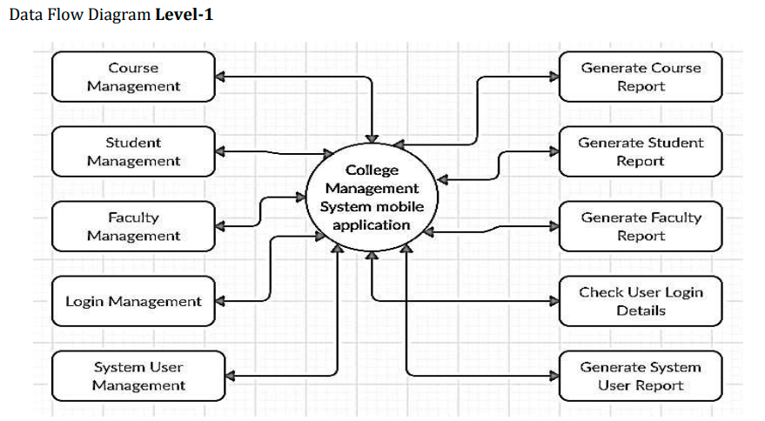

Figure 2: data flow diagram of ERP Level 1

Since the framework using the following technology to implement this ERP solution as follows:

1. Python programing
2. HTML CSS JavaScript
3. MYSQL 6
4. DJANGO (python web framework)

Since it was investigated that the DJANGO framework is not secured and not good but other python framework FLASK is works good and light weight. Since python framework FLASK works efficiently and good with programing interface.

## Implementation of Database using flask Framework

(Singh, M., Verma, A., Parasher, A., Chauhan, N. and Budhiraja, G., 2019) this research developed college database management system composed with educational institutes requirement. Python Flask is web based framework which integrate all applications that executes in all educational department and offices. This database solution offers various functionality which are support student, faculty and administrative level, hence student attendance and assignment marks also view by student by entering their credentials, student also able to view library content, syllabus content which are part of system and database application.

### Python Flask Features

1. Python flask easy to develop web based application, it is much better than DJANGO framework
2. Python flask is more better than Java framework due to less coding
3. Flask using the Jinja2 template engine
4. Flask deliver HTTP request support

## Conclusion of Literature Review

The literature finding are composed of ERP solution for academics and it’s also investigate with other ERP solution that facilitate, industry, sales, manufacturing, business etc. Since previous ERP for Educational institutes were not stable and not actively well, previous Java and ORACLE used but still issues and problem exists, research gap identified that FLASK base pure python application does not exist in previous literature studies so this research going to present unique and new development with advanced programing feature that support SQL function with POSTGRESQL in python flask framework.

1. MYSQL database Xampp server
2. Python FLASK framework
3. HTML CSS JavaScript

# Chapter # 3 Methodology

## Introduction

Methodology of this research planning to develop python application in which various programming interface includes database and other component of programing are involved to prepared novel ERP solution for educational institute. Enterprise resource planning in which various factor has been complicated the application in previous research so this finding make simple, easy, understandable application which support the academics.

## Research Philosophy

Evolution of ERP started in 1960, since various finding undertaken till 1990 in the invention of core ERP solution which support fully functional to organize and manage daily task of the organization and educational institutes. The term ERP was not invented until 1990, various investigations and findings has been taken to draw the attention. In 1960 connected centralized computer which shares and works on inventory control system hence data process in distribution way to optimize functions organize data in production system, MRP (Material requirement planning) software in association between manufacturer and IBM, the manufacturing organized in well manner in which the software automatic schedules of operation and procurement. Manufacturing process delivering goods from their factories organized customer order and manage stock in the MRP software, produced report according to the requirement of the customer. In 1980 MRP II designed by invention of CD the software seen the growth of manufacturing according to the requirement in manufacturing resource planning system II. Since the ERP concept started in 1990, system integrated with agile adaptations including market and business planning, since the concept of single database which support multi-functional, MRP software dissimilar the department such as marketing, finance, HR, with digital eco system.

## Research Strategy

1. Python Flaks
2. MYSQL DB
3. HTML CSS & JavaScript
4. Python libraries
5. Notebook & Pycharm

### Python Flask

Flask is micro web framework essentially part of python language, flask is better than DJANGO because of module conversion and application execution environment. Flask itself is python library of web, which import web layout framework during application running, flaks run like app in the python module, since flask application embed HTML and CSS JavaScript in order to make comprehensive application. Flask application executes on local host 127.0.0.1:5000, debugger is active and debugger pin code is 855-212-761.

### ERP in Flask

Enterprise resource planning system generate by using the web framework of python flask, including database connectivity to store and executes the student and faculty record. Since ERP system is part of business process management which allows academics to use system and integrated application including office files and desired data to be process in system. The basic objective of this work to ease the academic system such as small scale academics which have 500 capacity of student and 300 administrator including staff, faculty etc.

### Features of ERP Solution for Academics

1. Login/Signup
2. Add new user or login as administrator user
3. User profile including password and User profile
4. Online fee payment module, download fee voucher, see previous dues, submit fee
5. Announcement : for student academics and lecture related query
6. Requests: student request for supplies.
7. Faculty : post studies material , assignment material and result
8. Coordinator: allocate room for classes and prepare time table
9. Dean: see the student grades

### MYSQL Database

Database application works efficiently by installing database connection in python flask module. Python database creating web applications interactively by setting up the database environment and functionality.

1. Creating database with flask dB name
2. Creating database user in flask application
3. MYSQL DB installation in xampp server DB user works like administrator user
4. Installing the flask MySQL this library interact with the database using python
5. Setting up database in programing environments. Creating database table and enter records in the table such as student login, faculty login etc.

### HTML & CSS JavaScript

Hypertext markup language is web design language which interact with cascading style sheet, JavaScript and all these web designing modules embedded with python programing, all web design pages creating in flask application separately to interact with the flask modules and interface.

### Flask Python Pages

Flask python pages created to communicate between the database and main application web pages which executes web application in port number 5000 which executes in localhost environment. The following login environment created in database to communicate with the enterprise resource planning applications as follows:

1. Student Login (1)
2. Faculty Login (1)
3. Coordinator login (1)

### Login Profile

Student login profile enable them to view the notification which is posted by coordinator, time table of classes and rooms number, student generate request if needs any book, studies material etc. faculty login, which is part of provides the interface in which faculty can add assignment, add student grades etc. coordinator login which add time table and course material on site. Only one login and vice versa one login for faculty to test and implement this project.

### Data Collection Method

#### Research Data:

Secondary research data collected from Google Scholars, IEEE, MDPI, ACM library, JSTORE etc.

YouTube Video Tutorials:

Creating python application enterprise resource planning, this project taken help from YouTube video tutorials.

#### Research Positivism

Research positivism the approach of this research project scientifically proven by programing based experiment which helps the academics society to control and managed their educational resources in better environment. This research does not go beyond the boundary in which the society does not like to analyze.

#### Research interpretivist

This research analytical making practices of educational resources in real life practical solution based in which educational society would be beneficial to takes interest to enhance their educational resources through programing structure. Research project showing practices and practical interface between the student and faculty which showing positive interest in our society which generate observable outcome.

### Quantitative Method

Quantitative method of research measuring the research analysis method, statistic report has been prepared by evaluating the previous ERP solution and recent advancement of ERP solution which deals in all kinds of requirement of the higher education system.

## Research Analysis Method

Python programing analysis has been made in to test and execute the applications. This research is practically implemented works as project which is part of enterprise resource planning software, since ERP software actively works in producing high quality standard of academics, since ERP software now available open source and installable in windows operation system, but the issues is that these software are not fully updated to meet the functional and nonfunctional requirement of the academics institutes.

### Fused or Unfused ERP II

(Haddara, M. and Constantini, A., 2020) various academics using the online ERP solution system which might be able to fulfill the educational requirement in straight forward method, mostly the academics interested to support student assignment, time table and grades publication by providing student login vice versa applicable for faculty login as well. Since ERP digital platform to support timely decision making through which cover all aspects of business requirements of academics. This project focusing on faculty and student management into one platform which meets all the desired requirement of the student, recently student facing problem in assignment solving, lecture and studies material does not fulfill the gap between the lectures of students and faculty material, it was very hard to solves this complexity to facilitate student by such mean of interest which has relevant to their studies. In previous ERP comparative of customer relationship management in ERP solution which does act like works to prepared the method of studies into one platform.

### ERP Utilization Experience in UK context

(Elsayed, N., Ammar, S. and Mardini, G.H., 2021) this research investigate the utilized resource planning and the data disclose separately on manage and organize the enterprise resource planning system hence the context of corporate performance this research strained the financial constraint in context of studies method and data quality method. Hence quality assurance exists in every academic which measure the studies method which delivery by faculty member, since quality assurance method measure the quality of teaching and measure the skills of faculty by spreading evaluation sheet amongst the student.

### Quality Assurance in Higher Education

(Ghanem, S., 2020) Quality assurance department exists in every universities which enhance the method of teaching by collaboration between the deans and faculty meeting, quality assurance method measure the teaching skills level and student observing method, how teaching method is reflect the students mindset which deal their thought, mentality, and practical activity of student according to the given syllabus. Since quality assurance is all-inclusive method which meets all the processes relevant to studies material and teaching material method, since higher education commission set the criteria of teaching, if it applicable on faculty member which have the ability to teach the course in flexible manner. (Arshad, M., 2019) quality assurance department actively works in public sector and private sector universities at Pakistan, which make planning and which objectives to be measured and what outcome would be produced by the faculty this outcome applicable on future research or not practically seen all the observation in view of student points.

### ERP Small and Medium Enterprises UK

(Jayawickrama, U., Liu, S., Hudson Smith, M., Akhtar, P. and Al Bashir, M., 2019) there are 12 different types of ERP method implemented in UK SME, hence the core issues to facilitate customer management by using ERP solution method, hence ERP services has been measured by various research in thematic analysis observing the quality and interface of solution which sometimes crash and does not meet the exact running requirement of SME, the Thematic based analysis combined the 10 years literature and produced the high quality analysis, ORACLE ERP, Microsoft ERP, Amazon ERP, IBM ERP and open source ERP has been measured in this research the core issues identified that the educational institutes required ERP solution which part of customized based ERP.

### ERP SWOT Analysis

(Soliman, M. and Noorliza, K., 2022) this research investigated Egyptian university data and examine in SWOT analysis the survey was conducted on 112 Egyptian higher education institutes, which provides data on higher scale the measurement predict and analyze the what factor are affecting in ERP solution in alteration of ERP method at high education level, the ERP knowledge formulate the solution and suggest solution to remove the external and internal fence. This research suggest further research on ERP system needs more improvement and needs more investigation to fill the gap between the academics and student requirement. Comparative to old traditional database enterprise resource planning application which does not perform well due to negligence of system requirement as well user requirement, traditional old resource planning software does not perform better due to scalability and interconnectivity issues with the interface, since the system needs more accuracy and more improvement to design the enterprise resource planning application into the state of the art application which meet the educational need.

## Ethical Concern

This research does not harm any human being during investigation of data, this research does not part of any academics, which is not making for collecting cash and prize by doing these such task, this project enable me to investigate more in order to plan the enterprise resource planning solution to meet all the challenges and issues during designing the flask based web framework which meet the academic requirements, since it was observed in research literature various institutes does not clear their educational requirement because different schools have different requirement so one such investigating these parameter this research will meet all the schools educational requirement which means a lot for creative innovative python framework, flask framework is novel web framework which introduced MYSQL DB database, the database functionality works better, Flask works better with MYSQL DB database system, it minimize the efforts and time comparative java and C# programing, since python programing minimize the extra coding effort which enable researcher to creative effective web applications according to the requirement. Since python flask rich libraries of web interface module which executes in less effort by initialize the enterprise resource planning application, as we think the application think like our brain, if we needs to recall the database framework binding into the programing platform.

# Chapter #4: Result & Analysis

(Vogel, P., Klooster, T., Andrikopoulos, V. and Lungu, M., 2017) low effort analytics platform which analyze & visualize, web application are written in python flask programing since POSTGRE SQL database communications might be crashed sometimes alternative way to construct database with MYSQL server using Apache Xampp server technology. Flask is python web based framework in which ecosystem extension support developer application which are performed better comparative to previous web framework using Java, C#. flask library integrated with all web programming modules such as html, CSS & JavaScript, which perform better web experience fast, integrated reliable and achievable. (Mufid, M.R., Basofi, A., Al Rasyid, M.U.H. and Rochimansyah, I.F., 2019,) designing of model view controller which composed of CRUD operations, flask is micro web framework using the python language which is easy to understand and easy to implementation comparison to C++ and Java Programming, since if comparison with C# ASP.net python is better programing in all language platform.

## Result of Python ERP

## Home Page

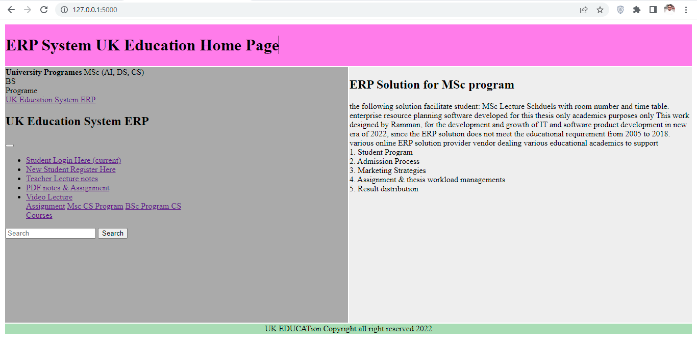

Figure 3: ERP System Flask App home page

The objective of this Python flask application equipped with HTML & CSS bootstrap application, since bootstrap quickly used to create the html &CSS web pages quickly, its support to develop web application python bootstrap plugin is major component of this project, to implement project by using the bootstrap plugin including html & CSS layer. Bootstrap plugin easily installed in python Pycharm by implementing creative web sheet awesome font’s style and background color. Web page layout also created by the bootstrap system.

Bootstrap FONT, HTML & CSS Templates in Pycharm Community Edition:

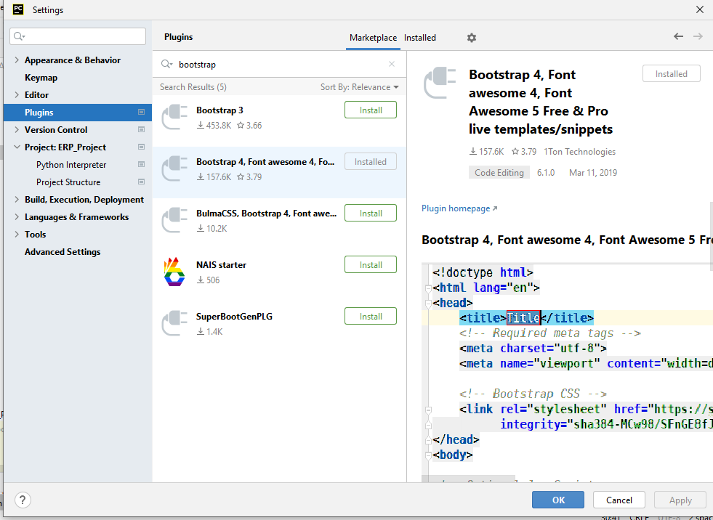

Figure 4: Python BOOTSTRAP HTML template

Since Pycharm community edition 2022.1.2 version contain various featured application with consecutives running applications suits, since the enterprise application composed with various planning of educational resources in which different educational resources has been involved. (Lokhande, P.S., Aslam, F., Hawa, N., Munir, J. and Gulamgaus, M., 2015.) Python programming is very efficient and intelligent way to design and implements python web based application using the flask framework, comparison with python DJANGO is not perform well, hence Django is complex to implement needs improvement and more research required to develop attractive web application. Web portal for student which support all desired requirement of student management system, the focus of this solution only based on MSc computer program which needs assignment, lecture notes, video and class schedules. The good themes and styles of web which attract more students to take admission in universities on the following mentioned program. Since flask is only web framework of python which fulfill all the requirements of web portal.

The database connection with MYSQL is very easy comparison to POSTGRESQL database system, which needs more research to communicate with web application in more organized manner. MYSQL database system using the Xampp framework which are more powerful system, the database library of MySQL database installed in python flask application before deploying the database connection of web applications.

## Register User page

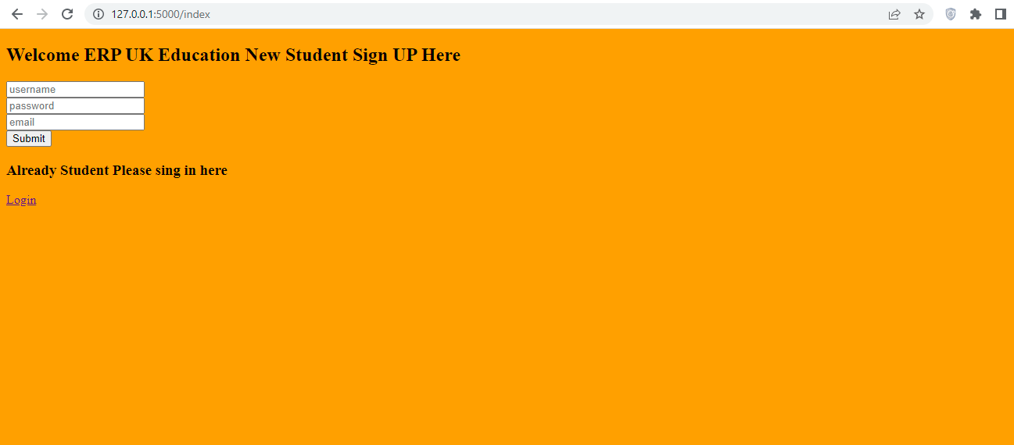

Figure 5: User Sign in Login Page

The flask and MYSQL database installing process as follows:

1. PIP install Flask MYSQLDB
2. Pip install MySQL-client
3. Pip install Flask

The following library should be installed in python Pycharm community edition version 2022. Register user page developed with HTML & CSS Bootstrap with backend database connectivity, user enter their credentials by username, password and email to register at the ERP portal. This ERP only designed for MSc Computer program student only. If the student already registered to the portal it would enter the username and password to get the home page of MSc.

## 3.Login PAGE

Login page design to manage the user profiles in which user can login their user profile to get the latest assignment & lecture notes. Login credential as should be followed the standard rules and regulations of the user management system such as username and password.

Email address of the user might be used for username and password criteria should be followed the password protection criteria to secure the login credentials. User management enable the administrator to see user email address and password credentials in database system.

Flask application for login page running in localhost port number 5000 on login page. The screenshot of running application has been taken as follows:

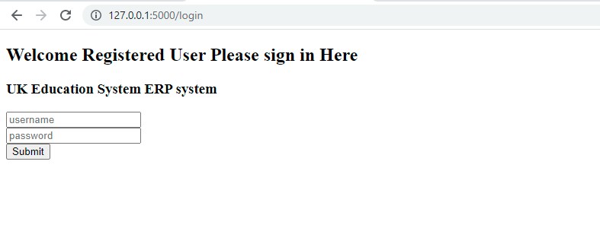

Figure 6: Registered user login page

In login page student login to the portal to get the home page which all full of resource planning to support only student.

1. Student Logged in to view Home Page

Student logged to their user profile to see the lecture slides, lecture notes pdf and video lecture online. Student able to get the latest assignment output on the particular page. Lecture schedule is clearly visible to the user page to see the lecture room and timing in overall week.

The following listing on user profile as follows:

1. Video lecture
2. Lecture PDF Notes
3. Lecture Slides
4. Lecture Schedules Weekly
5. Assignment uploaded
6. Due date of assignment mentioned.
7. Faculty meeting time listing
8. Notification and announcement is mentioned on user profile.
9. User management all credential is listed in the user profile to complete the all enterprise resource planning outcome.

ERP python file which is main file of application to executes all html render templates. Signup page login page and home page which controls all enterprise resource planning outcome to label the student management system.

## 4.User Profile Page:

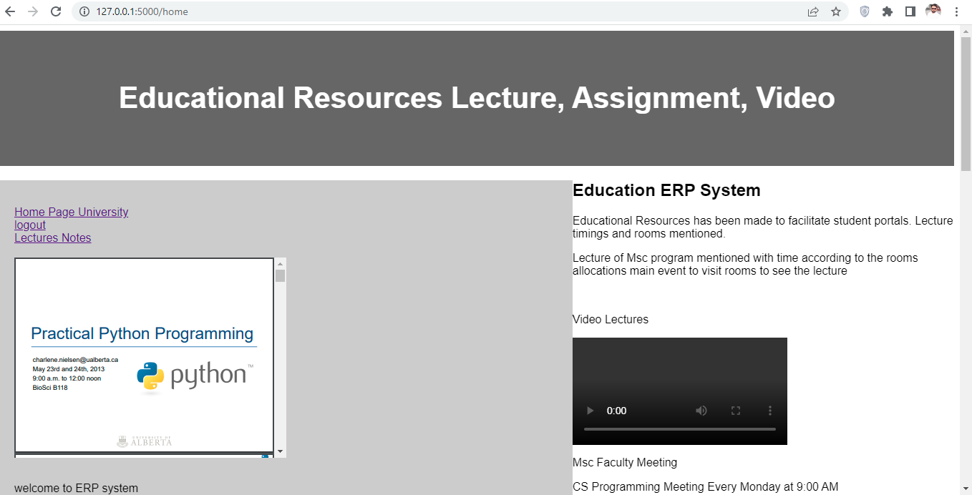 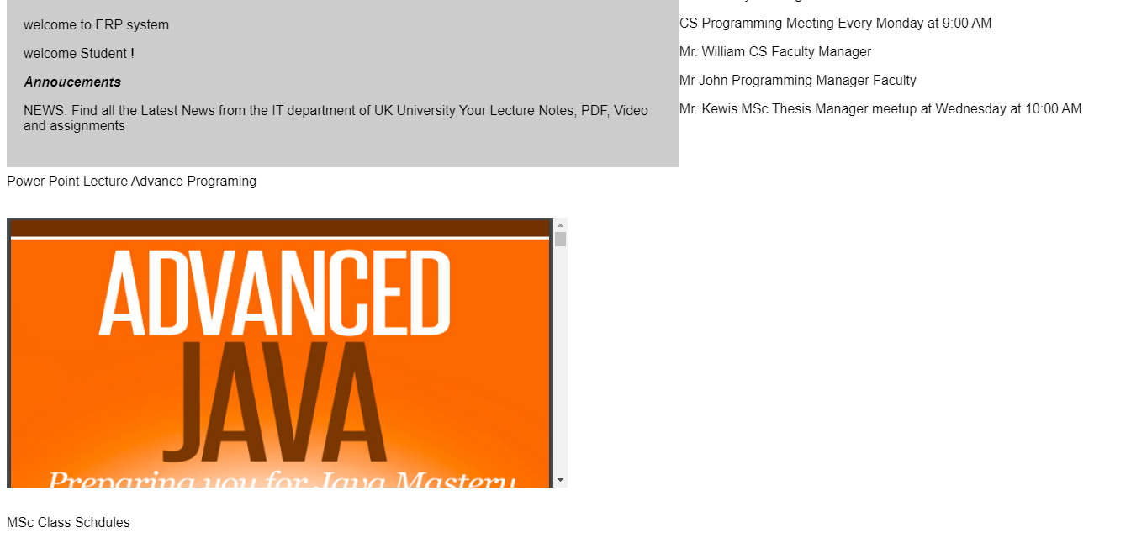

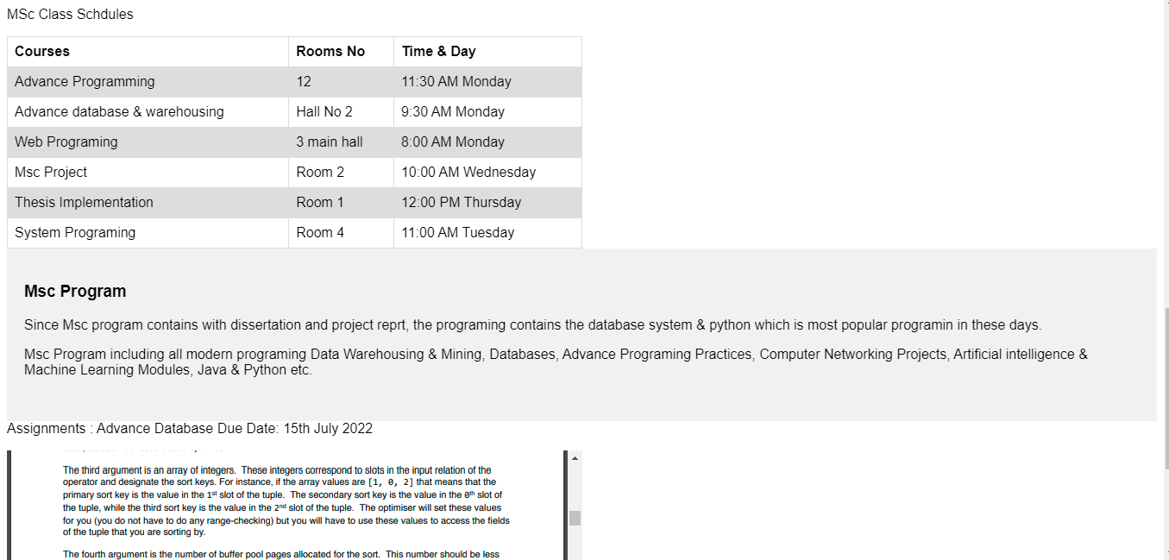



Figure 7: Complete ERP Registered User ERP page

## 5.Logged out to get home page again

User log out to their profile it will redirect to the home page in which user can view all latest announcements of the university portal, the main page of enterprise resource planning enable them user to get all the credentials of user management.

Main page listed with the following content as follows:

1. Sign up here
2. Login page
3. General Announcement
4. Assignment Announcement

Comparative to active directory LDAP login, this login system is web based system which connected with backend on database system, in this login management no needs to add user group management all user treated as individual group of user which belongs to single class only.

Home page appear when user log out to their login session. Each user see the login profile of same MSc program credentials.

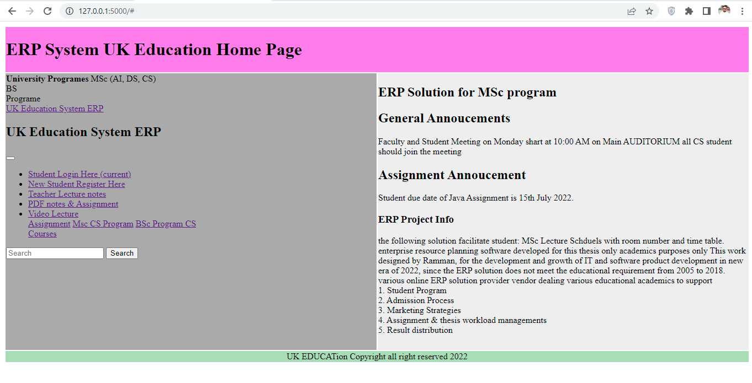

Figure 8: ERP Home Page after logged out

## 6. MYSQL Database

MySQL database is most commonly used database in the system which enhance the implementations of educational resources in the backend. (El Mohadab, M., Khalene, B.B. and Safi, S., 2017) integrated business process related to fee submission of student has been resolved by ERP system using the online system. Integrated intelligence areas such as workflow, management communication processes which organize to enhance the functional area. The reason to choose ERP software which delivers the competences, hence reason to choosing the common database which support all process management backend control and record keeping purposes. The objectives of database to executes financial query processing without delay, the common online ERP system paid license which does not fulfill the educational requirement. (Ahmed, F.Y., Sreejith, R. and Abdullah, M.I., 2021), enhancement of ecommerce database system using the PHP myadmin database system, the overall functionality of MySQL database system user friendly interface.

Database creation process carried out as follows:

1. Create new database 🡪 flaskdb
2. Create new table 🡪 users
3. Add attributes name and data type values in the table as clearly seen below:
4. Id: int length 11, name: varchar length 150, email: varchar length 150, password varchar length 150.
5. SQL query processing system works efficiently to process the database query.
6. Database import/export process which integrate to export the project to another location and computer.
7. Database running in localhost.
8. Browse the query to delete the recorded entry in the database system, recorded database delete when the information is not required.

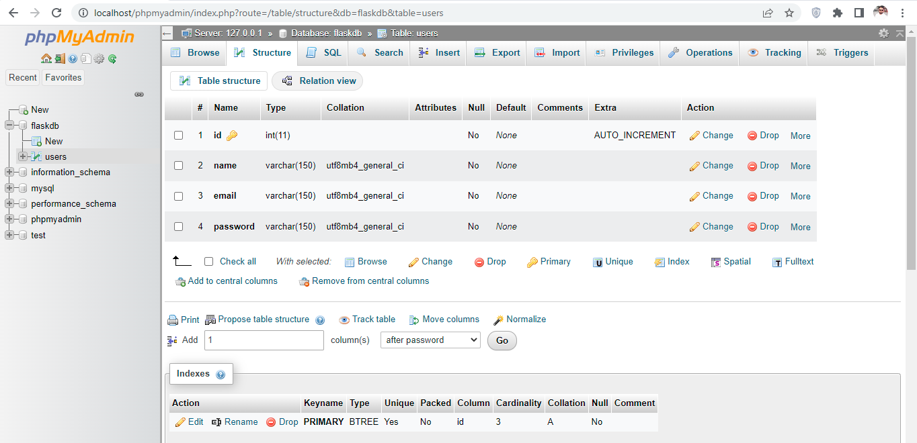

Figure 9: PHPMYADMIN MYSQL database

Database record which represent the user id name and email address followed by user password, which is necessary action to keep the user record to manage the enterprise resource planning system in the database system. The new record adding in the flaks website when user creating their new credential the necessary action has been taken to process the query in action to process the educational resources.

Database system enhance the visibility experience of python website to deploy the student friendly studies management system according to the UK standard requirement.

UK educational system manage by various online paid ERP system, e.g. Microsoft, Amazon, ORACLE etc. but still the requirement needs to modified according to the educational standard requirement, so needs to deploy the system again by implementing the customize system with python flaks micro web frameworks.

## 7.Database Records

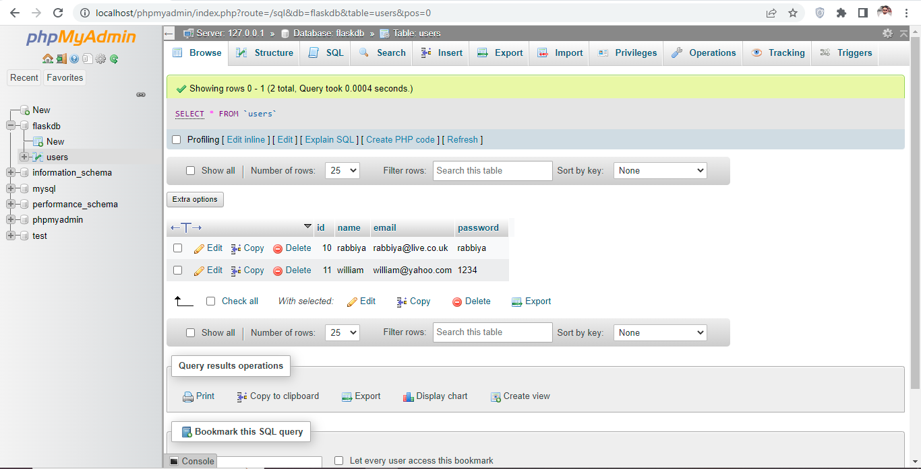

Figure 10: Database record

## 8.Python ERP Project

(De Carvalho, R.A. and Monnerat, R.M., 2008) deployed previous project in python programming hence this project is more efficient than previous one, implementing enterprise resource planning projection which capture the necessary information in order to process and reflect the code.

In this project the coding process admired by python main file which used to execute the app route files using the python main function. Render templates contain html & CSS files.

The following templates executes from the main route ERP files as follows:

1. Main HTML
2. Signup HTML
3. Home html
4. Login html
5. 404 html
6. Style css file

* In the login and registration process the post method implemented to process the query in the database system in MYSQL system.
* Python login and login check function implemented to verify the login credentials entered by user during the login process.
* Main app route file executed through render templates which contains html main file.
* CSS templates followed from the Google bootstrap sites. (bbbotrap 2021)
* HTML coding sequences followed from the bootstrap template (getbootstrap 2021)
* Python coding implemented by learning video lectures from YouTube video tutorial sites.
* Python implementation has been carried out to resumes all the functionality through the protocol layer of 5000 by running the flask app in the browser though local host.

## 9.Python Code Review

The following screen presented the python coding view.

1. ERP main python file
2. Render templates includes all HTML files contain the login, logout, home and main page.

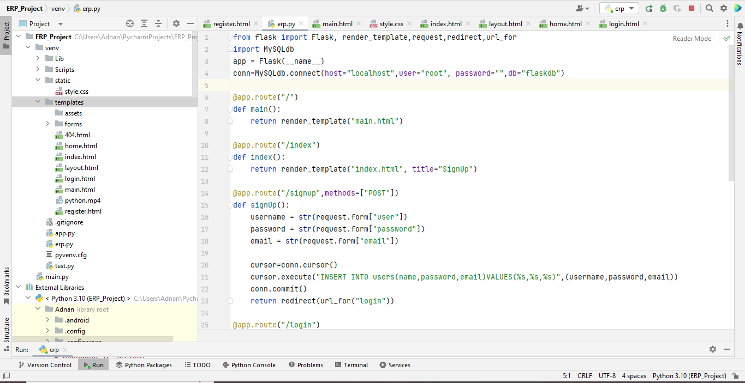

Figure 11: python coding overview

Python flaks is micro web frameworks to process the complex database operation in browser, since the database system implemented through the MySQL server.

## 10.Python Packages

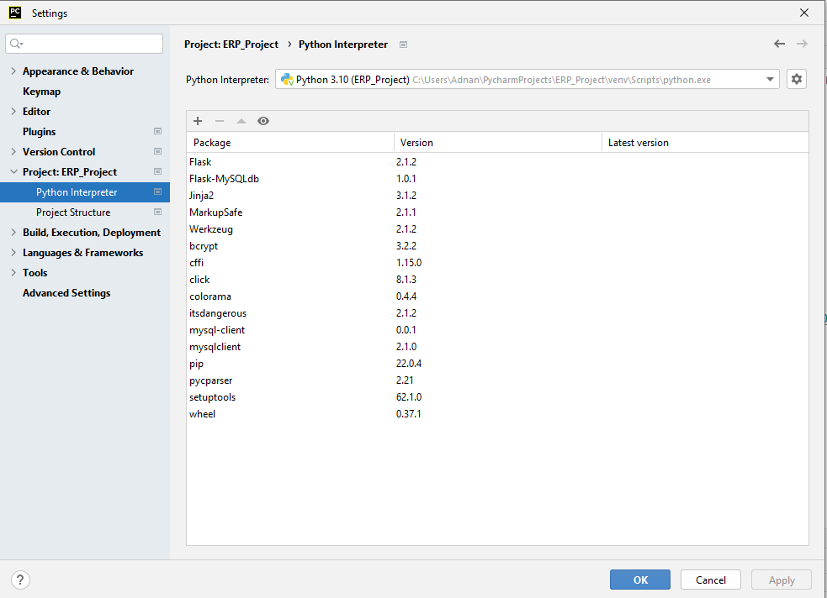

Figure 12: python packages in pycharm

Python packages includes the python library needs to installed in the Pycharm community edition 2022 version to process all credential of ERP project.

## 11. Critical Analysis

(Mutongwa, M.S. and Rabah, K., 2013) ERP system solution proposed to process the small and medium task on web which facilitate the educational resources, hence ERP is integrated information system, the increasing demands of ERP system which integrated with various module, objectives of this research to develop ERP system to process small and medium enterprise industries, but comparison with education system needs to refurbished them. (Zhou, C., Zhou, T. and Bai, W., 2018,) key finding of this project to implements smartphone NFC technology using the ERP system hence the near field communication which is based on short range communication technology which combines the ERP data streams on the phone. This research using the cross platform third party tool to support android phone user which customized short range communication method to view ERP resources on their telephone screen. Since the security of short range is challenging to secure the end to end encryption.

## 11.1 Sentiment Analysis

This research proposed (Sarlan, A., Nadam, C. and Basri, S., 2014) twitter sentiment analysis based on machine learning method, twitter is most common social media platform backed process by enterprise resource planning system on regional based, result carried on python DJANGO framework to analyze the positive and negative feedbacks of customer on twitter database.

## 11.2 Enhancing Automation using python code Injection

(Novak, P., Douda, P., Vyskočil, J. and Wally, B., 2021) industrial 4 revolution corresponding to preproduction processes under production resource process. Automation process carried out using python script injection to represent needed information on the web which demonstrate industry 4 testbed.

## 11.3 Big Data ERP IOT Projection

(Sun, G., Huang, Z. and Yue, L., 2022) intelligent decision system process bit data analytics using ERP system and design the intelligence support system in automotive supply chain business. Python script test the ERP script which executes fast in less time compare to java, c# ASP, and python is much better than any other platform.

## 11.4 Developing Module Generation for ODOO using Low code development platform

(Cooharojananone, N., 2021) ODOO is open source ERP software designed in python programing which combines various business requirements hence ODOO is open source tool in which the organized software approach which mitigate the coding schemes which exists in C++, Java, ASP programming. Python is web based framework which enable them to captures all necessary requirement related to educational resources. The software development module framework usually works to executes all framework into web framework. Software development typically on less coding schemes which enhance the visibility of tool in more organized manner and minimize the complexity in software tool. ODOO software developed in low coding environment and less complexity framework since the concept of software solution its web platform framework which creates the module with less concern about errors and more organized focused on logical framework of programming. The web based developed framework which enhance the software requirements, beside this there is requirement on higher educational enterprise resource planning which should be based on open source like ODOO framework, the research gap still exits to meet all higher educational requirements. The platform is web based to access all web framework modules in which to enhance the modules visibility. Developer used application modules to minimize the coding part, various open source ERP solution available online but the issues exists to meet the educational requirement.

## A roadmap for migration system architecture decision by Neutrosophic ANP Standard for ERP

(Saleh, A.A., 2021) software migration tool package migration available to migrate from one platform to other platform. Software engineering lifespan would be used to mitigate the approach suitable architecture to meets the software solution. The increase instances of software oriented architecture should meet the business resources and financial resources hence the objectives to plan the financial related services, the management organized the finance software solution which enhance the software visibility. The software architecture evaluate and validate the software solution, the lack of software implementation projection which needs to improve them in order to execute in more sophisticated manner. UML and database binding is another challenging task in the past now the database solution has been designed which based on web framework that increase the data creation and storing procedure. OpenBravo ERP, ODOO12, Metasfresh 5.144 to represent the enterprise resource planning modules in more organized manner. The software standard assessment modules planned with diverse nature of business requirement it updated according to the novel requirement which might be able to update all software modules automatically. Business simulation processes would be the better way to organize the system modules. The objectives of empirical studies approach will increase the software requirements according to the diverse nature of software solution.

## Implementation of Container based Parallel system for automation software testing

(Chuchuen, Y. and Rattanaopas, K., 2021,) software quality assurance is major factor during the testing of software components and layers. Each module tested based on the business and educational requirement. In these days automatic software testing has been deployed with modern robot framework of Selinium2. Additionally the software testing is based on black-box testing which would meet the software functional requirement. The key concepts of software parallel and single testing laid down to identify the software modules database binding has been tested according to the software running requirements. The selenium2 robot engine testing the software framework critically in order to enhance the software visibility which generates more business. Beside this DOCKER framework is another common software testing module to test thoroughly the each software module. The software testing modules presents the results which based on the CPU testing which also identify the software testing modules.

## Higher Education ERP Solution

Since python enterprise resource planning system to reach the educational goal, since the python programming, school administration, human resource and financial management, higher education system support academic, process in colleges and universities such as exams, grades, tuition building, billing to scheduling the process over the administration process has been maintained through the ERP solution which previously design on administration process to mitigate the schemes. The administration process which organized the mitigation process academics college administration nature running educational, the educational resources to process which holds the several processes the operation process has been discussed and planned according to the nature of business theory.

Since the academic solution are designed to process the educational resources, several educational resources organized, teacher administration and beyond. Fully integrated process vendors talking universities to view the complex project. Student, teacher and administration best-practices for best administration to control the process.

## Features of Higher Education ERP systems

Student information system since the stored procedure details of students, allow the student to register for classes, the administration process organized managed through to manage the track institutional goals. Since the human resource management are designed to organize and managed the different objects. The time sheet, leave request and compensations which identify the right candidates via talent management, track the tenure system which process the different complex task, since the financial services managed through the organized projections educational institutes, budgeting, payroll, payable account, procurement and requisition and grant certifications. Financial aid management. Handle awarding to review the payment process, their account the calculations of organized task which analyze the report which needs in robust manner.

## Benefits of Higher Education ERP Systems

The benefits educational ERP system institutes helps to achieve the certainty of different objects, since the objectives of higher education system has been maintained by IT administrator to enter the student managing since the university library system has been organized managed through the centralized which including fee processes, monitoring the student grades and sending the query which are maintained by the information management system. The college and university system has been implemented and proposed by university administration to achieve the certain complex task based on admission process, student enrollment process, fee processing, hence the alumina process the higher education studies schemes the college community organized with several task to obtain the better result which are proposed on objective themes of business operations. Some of the top benefits of ERP education system which are used to obtain the better result such as largely privately running private application to draw the attention which are organized to meet the business objectives. Since the top benefits of higher education ERP system proposed on different attribute based object classification method which meets the student and faculty requirements.

## Manage Student information effectively

Colleges and universities which needs higher education to compete the business processes to achieve the business logic operations. The correctly deploy ERP solution which are proposed on best programming logic to enable them the collected data and information to process the certain task in order to maintain to process the data and information. The academia management solution which learning on certain objects to classify the certain objects to meet the objectives of business logic. The business requirement would meet the business logic requirement since the ERP software implementations to organize the business logic operation to process to organize academics.

The compliance business requirement which meets the educational requirements to meet the certain objects, since the educational ERP implementation system, the digital implements should be maintained on the business logic operations. Since the truly implementation of ERP solution which meets the business logic operations to process the several complex task on the desired requirements of internal operations. Communication business logic operation processes on higher education system to process the several business logic operations since the several communications process has been maintained and process the educational resources previously attempt to achieve the business logic operations. The departments of college which actively works to achieve the certain object based classification to design the business operations.

## School Management System

School management software system which automate the business logic operations to process the involved tasks which are running by educational institutes, since the higher education ERP software system executes all schools requirements which are based on the business logic operation and student admission process leading towards the student enrollment process. Higher education learning process which are used to organize the systematic approach of business classification to achieve the object classification models related to secondary data model. Various refers to ERP software classification which achieve the business model that executes the certain task on intent based software classification, since the true implementation of ERP solution are designed to minimize the business complexity by achieving the certain objects based task execution, the object based classification are executed on different modules based segmentation, K-12 schools which are needs to classify the universities school object classifications on the certain object based execution modeling since the intent classification pattern achieve the model testing goals to draw the attention of university administration processes.

## Student information System

Student information system of MSc level which are available on ERP software by achieving the several complex tasks, student access their records by achieving the certain to apply the several which in view to draw the academic services, review the business operations which achieved the educational resources to achieved the tasks, semester course offerings are designed to meet the desired educational requirement on certain parameter.

Student, Faculty and university administration process which monitor the several business operations to monitor and organize the educational resource, educational resources has been targeted by the university resources to allocate the systematic approach of business layer which deeply concerned on business operations.

Since the student information system also admired the true logic operations of business layer the learning management system (LMS) which facilitates the administering, documenting , tracking, reporting and delivery the educational resources. Since the student learning management system actively works on daily task based achievement which draw the attentions such as education resource executions, school administration execution, students are actively works on major requirements to deal the business operations, classification based approach signup, and sign in operations to achieve the certain tasks which makes conclusion to draw the certain tasks. The student can takes interest to tracking the educational resources, the educational resources executed by modules based classification to meet the certain task message, requirement, teacher meeting requirement submit to homework based classification to executes the business operations.

## School administrative software ERP

Since the school administrative related query are processed and executed by student faculty management to achieve the business operations. Administration and schools attendance system executed by the departmental management, faculty management, even the student health record management, hence the university administration process achieved through the several business logic layer and student information system logic layer and modules which executes both of the task to facilitate the student community in real time. Educational resource management system proposed the maps to draw the systematic approach to meet the business operations which are based on organized systematic approach, since the objectives of higher studies is achieved through the certain business classification to enhance the finance flow, the ratio of maximum admission process. The university administration would takes interest by marketing campaign which also organized by the ERP software solutions, since the implementations of ERP software should maintained through the web based ERP solution which executed by different student based on different domain based executions. Since the implementation of ERP solution also energized the business operation to meet the certain task of business layer. Since the real implementation of ERP solution which would designed by software developer which are based on business layer to meet all the necessary requirement that are deal by the university admission system.

Financial and asset management system which needs to recover through the online admission fee process, student enrollment process, student payroll management system encouraged to use by the ERP software. Since the real implementation of ERP solution which are designed to process the several business operations and process which are designated based on the requirements of educational resources.

Meanwhile ERP system manage & prearranged numerous instructive capitals system which adapted the advance technology hence implementation of ERP system to provision schools and Colleges of UK which needs customized support to achieve the objective of educational resources. In previous releases of ERP software which does not perform better according to the educational needs and requirement. The implementation of real ERP resource planning system which includes various complex functionality that process the finance management with educational resource management. Various online educational resource management system available but the lack of business requirement which exist the major gap to manage the educational resources. Hence enterprise knowledge management system which organize the way of meeting to conduct online session to meet the student forums.

# Chapter # 5 Discussion & Conclusion

Python application works efficiently due to its ability of integrated online libraries, enterprise resource planning application organized and manage the educational resources. Python flask which is web framewrok to process the resource planning task to support educational requirement to executes resources on web based application. Previous ERP was very complex and not accurately works well, due to lack of educational requirments hence oracle database applications which is more complex to organize the systematic task. Online open ERP system is not match the educational resource planning requirement which is not working well. Beside this Amazon, ORACLE, Azure, IBM cloud providing cloud based online enterprise solution which is much costly and which does not meet the student and faculty requirement to process the educational needs. Since overall educational resources system change their requirement on frequent time which adds more complexity and complex features, so enterprise solution changing & modification permitted in order to increase the criteria.

Python programing is light weight and good GUI interface which has less coding features compartive to Java, C# ASP, C++ etc. It is suggested and recommended by various programmar and researcher that python programming is more supportive than any other of that, so the interface of flask web which needs only installable library packages to process the web application into web browswer. The limitation is very vast and appealing the criteria of resources which enhance the featured application to be processed and updated according to the given requirement.

(Costa, C. and Aparicio, M., 2006) organizational tools in the web open ERP solution which support online web based organization resource planning hence ERP solution is open source planning solution which support in many fields that has integrated with different tools & technique, since large number of organization does not afford costly ERP solution which has limited resource to organized and mange employees and customer records. Since open source ERP solution which is not free of cost but some modules might be available freely to use them but limited capacity.

## Comparative Discussion of Open Source ERP Software

(Bajaj, S. and Ojha, S., 2016) in today worlds ERP system is much complex to meet the business needs since ERP solution is solution to solves all business needs which has integrated on various business functions. ERP solution which support small and medium enterprises organization, ERP5 is fully featured open source online ERP solution which meets the business requirement which providing the industry solution with more than 300 employees in 5 different global cities. Common functions of ERP5 is as follows:

1. CRM customer relationship management
2. Product Data Management
3. Manufacturing requirement planning
4. HRM
5. E-Commerce

### TINY ERP (OPEN ERP)

Tiny ERP is known as open source ERP solution which are available on desktop edition and android mobile edition to support different kinds of problem, the architecture and styles of TinyERP is like open ERP solution constructed like SQL database functions.

### SQL ledger

SQL ledger is web based ERP solution system which executes on windows operating system and Mac system which support small size and micro size organization functionality. Hence the entire system of SQL ledger which linked through the chart like inventory and accounts functionality mostly support finance application in common.

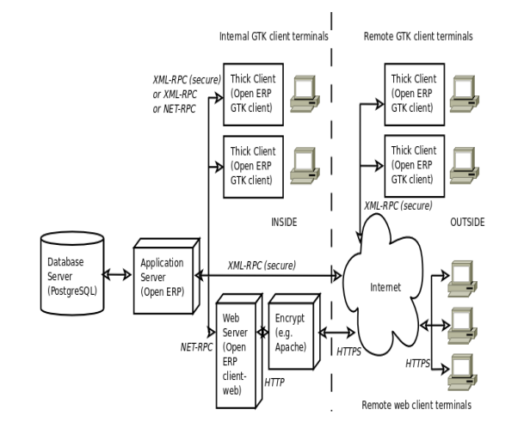

Figure 13: Architecture of OPEN ERP

## Automated Software Architecture Security Risk Analysis

(Almorsy, M., Grundy, J. and Ibrahim, A.S., 2013) reviewing the literature which suggest some comprehensive solution to meets the desired requirement according to the functionality of system development hence the software development life cycle needs security life cycle to secure the internal file system of ERP software. Since object constraint language (OCL) which uses the signature to target the system to locate signature matches and capture the internal data of the system and spoil them in bad manner. Since NIST security principle which attacked on database system based on CAPEC, so needs to improve them in order to run the software more appropriate manner.

## OPEN SOURCE ERP to Support Chicken Meat Processing Company

(Vanany, I., Maftuhah, D.I., Soeprijanto, A. and Zulhafizh, M., 2019) the objectives of this research to produces the best quality halal meat and distribute them in which the requirement is occurred, OPEN source ERP solution is best way to organize these types of system. Chicken Meat Company is used as case studies of this research to identify the processing of ERP software hence the large amounts of target subsidiaries system needs efficient data processing system to support customer in online. To model the database relationship using the use case diagram of software which ensures the number of target process in OPEN source ERP software, the solution considered to process payment transactions online in best predicted manner which has valid reason.

## Effective ERP Solution based on Case Studies

(Grobler-Debska, K., Żak, B., Baranowski, J., Kucharska, E. and Domagala, A., 2021) ERP solution composed of decision making solution which process customer, handle product manufacturing process which also suggest solution based on different complexity. Hence the application of POLISH company which uses the mass customization pharmacy industry to process medication requirement.

## Recommendation & Solution

It has suggested and recommended from various previous researches that OPEN source ERP solution which support only industrial application such as small and medium organization. Since large organization required customized ERP solution based on real python programming which meet the requirement. OPEN source ERP solution which does not meet the educational requirement in real situation. Python Flask application is best choice to predict and analyze the student problem to model educational resources in more effective way.

Python and MYSQL database system works very well to organize the MSc program enterprise resource planning applications. It has been recommended that the requests is decent to used and easily configure and wieldy. It has been noted that the student would enable them to achieve the systematic approach in order to maintain the teaching objectives, syllabus progress updated on priority in which the different teaching fellows query has been maintained them. Since the modern ERP software is based on modern online database storing system which stores teaching records on online database system, it has been noted that the each professor answer the student query instantly by deploying the online system. The target and assigned teaching objectives has been achieved in which the teaching and learning objectives has been achieved on the following parameter to answer the query. Educational enterprise resource planning system enable them to captures the systematic and organized approach to maintain the teaching progress on priority.

# References

Soliman, M. and Karia, N., 2016, March. Enterprise resource planning (ERP) systems in the Egyptian higher education institutions: Benefits, challenges and issues. In *International Conference on Industrial Engineering and Operations Management, Kuala Lumpur, Malaysia* (pp. 1935-1943).

Abugabah, A. and Sanzogni, L., 2010. Enterprise resource planning (ERP) system in higher education: A literature review and implications. *International Journal of Human and Social Sciences*, *5*(6), pp.395-399.

Allen, D., Kern, T. and Havenhand, M., 2002, January. ERP Critical Success Factors: an exploration of the contextual factors in public sector institutions. In *Proceedings of the 35th Annual Hawaii International Conference on System Sciences* (pp. 3062-3071). IEEE.

Pollock, N. and Cornford, J., 2004. ERP systems and the university as a “unique” organisation. *Information technology & people*.

Klaus, H., Rosemann, M. and Gable, G.G., 2000. What is ERP?. *Information systems frontiers*, *2*(2), pp.141-162.

Surendro, K. and Olivia, O., 2016. Academic cloud ERP quality assessment model. *International Journal of Electrical and Computer Engineering*, *6*(3), p.1038.

Noaman, A.Y. and Ahmed, F.F., 2015. ERP systems functionalities in higher education. *Procedia Computer Science*, *65*, pp.385-395.

Soliman, M. and Karia, N., 2015. Enterprise resource planning (ERP) system as an innovative technology in higher education context in Egypt. *International Journal of Computing Academic Research (IJCAR)*, *5*(4), pp.265-269.

Aldayel, A.I., Aldayel, M.S. and Al-Mudimigh, A.S., 2011. The critical success factors of ERP implementation in higher education in Saudi Arabia: A case study. *Journal of Information Technology & Economic Development*, *2*(2).

Abdellatif, H.J., 2014, September. ERP in higher education: a deeper look on developing countries. In *2014 International Conference on Education Technologies and Computers (ICETC)* (pp. 73-78). IEEE.

BE, D., 2021. Consequence of Enterprise Resource Planning in the Environs of Pedagogical Organization. *Journal of scholastic Engineering Science and Management*, *1*(1), pp.1-6.

Lervik, A., Riccardi, E. and van Erp, T.S., 2017. PyRETIS: A well‐done, medium‐sized python library for rare events.

Python, G., Fargier, R. and Laganaro, M., 2018. ERP evidence of distinct processes underlying semantic facilitation and interference in word production. *Cortex*, *99*, pp.1-12.

Ganesh, A., Shanil, K.N., Sunitha, C. and Midhundas, A.M., 2016, February. Openerp/odoo-an open source concept to erp solution. In *2016 IEEE 6th International Conference on Advanced Computing (IACC)* (pp. 112-116). IEEE.

Saabith, A.S., Fareez, M.M.M. and Vinothraj, T., 2019. Python current trend applications-an overview. *International Journal of Advance Engineering and Research Development*, *6*(10).

Jindal, N. and Dhindsa, K.S., 2013. Comparative Study of OpenERP and its Technologies. *International Journal of Computer Applications*, *73*(20).

Gao, L., 2020. Exploring the data processing practices of cloud ERP—A case study. *Journal of Emerging Technologies in Accounting*, *17*(1), pp.63-70.

Devkota, A., 2016. Open ERP Odoo guidebook for small and medium enterprises.

Destefanis, G., Counsell, S., Concas, G. and Tonelli, R., 2014, May. Software metrics in agile software: An empirical study. In *International Conference on Agile Software Development* (pp. 157-170). Springer, Cham.

Abbas, A.A., Abdel Mahmoud, A.A. and Abdallah, M.M., 2015. *SOFTWARE AS A SERVICE ERP SYSTEM* (Doctoral dissertation, SUDAN UNIVERSITY OF SCIENCE & TECHNOLOGY).

Christianto, M.J., 2022. OpenBravo ERP in Enterprise Company. *Jurnal Sosial Teknologi*, *2*(2), pp.142-152.

Mladenova, T., 2020, October. Open-source ERP systems: an overview. In *2020 International Conference Automatics and Informatics (ICAI)* (pp. 1-6). IEEE.

Sharma, V., Kumar, R., Sharma, R., Mutreja, R. and Vargis, B., 2020. Django Framework based ERP for an Institution.

Singh, M., Verma, A., Parasher, A., Chauhan, N. and Budhiraja, G., 2019. Implementation of Database Using Python Flask Framework. *International Journal of Engineering and Computer Science*, *8*(12), pp.24890-24893.

Haddara, M. and Constantini, A., 2020. Fused or Unfused? The Parable of ERP II. *International Journal of Information Systems and Project Management*, *8*(3), pp.48-64.

Elsayed, N., Ammar, S. and Mardini, G.H., 2021. The impact of ERP utilisation experience and segmental reporting on corporate performance in the UK context. *Enterprise Information Systems*, *15*(1), pp.61-86.

Arshad, M., 2019. Current trends and issues in quality assurance practices: higher education Pakistan.

Ghanem, S., 2020, November. E-learning in Higher Education to Achieve SDG 4: Benefits and Challenges. In *2020 Second International Sustainability and Resilience Conference: Technology and Innovation in Building Designs (51154)* (pp. 1-6). IEEE.

Jayawickrama, U., Liu, S., Hudson Smith, M., Akhtar, P. and Al Bashir, M., 2019. Knowledge retention in ERP implementations: the context of UK SMEs. *Production Planning & Control*, *30*(10-12), pp.1032-1047.

Soliman, M. and Noorliza, K., 2022. Adopting enterprise resource planning (ERP) in higher education: a SWOT analysis. *International Journal of Management in Education*, *16*(1), pp.20-39.

Vogel, P., Klooster, T., Andrikopoulos, V. and Lungu, M., 2017, September. A low-effort analytics platform for visualizing evolving Flask-based Python web services. In *2017 IEEE Working Conference on Software Visualization (VISSOFT)* (pp. 109-113). IEEE.

Mufid, M.R., Basofi, A., Al Rasyid, M.U.H. and Rochimansyah, I.F., 2019, September. Design an mvc model using python for flask framework development. In *2019 International Electronics Symposium (IES)* (pp. 214-219). IEEE.

Lokhande, P.S., Aslam, F., Hawa, N., Munir, J. and Gulamgaus, M., 2015. Efficient way of web development using python and flask.

El Mohadab, M., Khalene, B.B. and Safi, S., 2017, November. Enterprise resource planning: Introductory overview. In *2017 International Conference on Electrical and Information Technologies (ICEIT)* (pp. 1-4). IEEE.

Ahmed, F.Y., Sreejith, R. and Abdullah, M.I., 2021, April. Enhancement of E-Commerce Database System During the COVID-19 Pandemic. In *2021 IEEE 11th IEEE Symposium on Computer Applications & Industrial Electronics (ISCAIE)* (pp. 174-179). IEEE.

De Carvalho, R.A. and Monnerat, R.M., 2008. Development support tools for enterprise resource planning. *IT professional*, *10*(5), pp.39-45.

<https://bbbootstrap.com/snippets/bootstrap-student-login-form-61721837>

<https://getbootstrap.com/docs/4.0/examples/>

Mutongwa, M.S. and Rabah, K., 2013. ERP system solutions for small and medium enterprises in Trans Nzoia County–Kenya. *Journal of Emerging Trends in Computing and Information Sciences*, *4*(11), pp.869-876.

Zhou, C., Zhou, T. and Bai, W., 2018, April. The key study of the integration between smartphone NFC technology and ERP system. In *2018 IEEE 3rd International Conference on Cloud Computing and Big Data Analysis (ICCCBDA)* (pp. 500-505). IEEE.

Sarlan, A., Nadam, C. and Basri, S., 2014, November. Twitter sentiment analysis. In *Proceedings of the 6th International conference on Information Technology and Multimedia* (pp. 212-216). IEEE.

Novak, P., Douda, P., Vyskočil, J. and Wally, B., 2021, September. PyAML: Enhancing AutomationML for Advanced Virtualization of Industry 4.0 Cyber-Physical Production Systems with Python Code Injections. In *2021 26th IEEE International Conference on Emerging Technologies and Factory Automation (ETFA)* (pp. 01-08). IEEE.

Sun, G., Huang, Z. and Yue, L., 2022, January. Towards Advanced Resource Management and User-friendly Delivery in Blended Learning. In *2022 IEEE 2nd International Conference on Power, Electronics and Computer Applications (ICPECA)* (pp. 191-197). IEEE.

Sun, G., Huang, Z. and Yue, L., 2022, January. Towards Advanced Resource Management and User-friendly Delivery in Blended Learning. In *2022 IEEE 2nd International Conference on Power, Electronics and Computer Applications (ICPECA)* (pp. 191-197). IEEE.

Kendle, A.S., Nagare, M.S., Patre, H.G., Zanwar, R.S., Kottawar, V.G. and Deskhmukh, P.B., 2021, May. TnP Vision: Automation and Analysis of Campus Placements in Colleges. In *2021 5th International Conference on Computer, Communication and Signal Processing (ICCCSP)* (pp. 1-6). IEEE.

Sisyukov, A.N., Bondarev, V.K. and Yulmetova, O.S., 2020, January. ERP Data Analysis and Visualization in High-Performance Computing Environment. In *2020 IEEE Conference of Russian Young Researchers in Electrical and Electronic Engineering (EIConRus)* (pp. 509-512). IEEE.

Kumar, A. and Gupta, P.C., 2012. E-KMS: a KM tool for educational ERP system. *Procedia-Social and Behavioral Sciences*, *65*, pp.682-687.

Kulkarni, A., Hegde, N., Sharma, M., Kulkarni, A.A., Hegde, N. and Sharma, M., 2015. Educational ERP systems in the market–a comparative study. *International journal of innovative research science in technology*, *1*(8), pp.84-91.

Kumar, A. and Gupta, P.C., 2012. Identification and analysis of failure attributes for an ERP system. *Procedia-Social and Behavioral Sciences*, *65*, pp.986-991.

Qian, L., Schmidt, E.K. and Scott, R.L., 2015, December. ERP pre-implementation framework for Higher Education Institution: A case study in Purdue University. In *2015 IEEE International Conference on Industrial Engineering and Engineering Management (IEEM)* (pp. 1546-1550). IEEE.

Bologa, R., Bologa, A.R. and Sabau, G., 2009, November. Success factors for higher education ERPs. In *2009 International Conference on Computer Technology and Development* (Vol. 1, pp. 28-32). IEEE.

Costa, C. and Aparicio, M., 2006. Organizational tools in the web: ERP Open Source. In *Proceedings of the IADIS International Conference on WWW/Internet* (pp. 401-408).

Bajaj, S. and Ojha, S., 2016, March. Comparative analysis of open source ERP softwares for small and medium enterprises. In *2016 3rd International Conference on Computing for Sustainable Global Development (INDIACom)* (pp. 1047-1050). IEEE.

Almorsy, M., Grundy, J. and Ibrahim, A.S., 2013, May. Automated software architecture security risk analysis using formalized signatures. In *2013 35th International Conference on Software Engineering (ICSE)* (pp. 662-671). IEEE.

Vanany, I., Maftuhah, D.I., Soeprijanto, A. and Zulhafizh, M., 2019, December. Modelling Halal Internal Traceability in Open Source ERP System for Chicken Meat Processing Company. In *2019 IEEE International Conference on Industrial Engineering and Engineering Management (IEEM)* (pp. 1017-1021). IEEE.

Grobler-Debska, K., Żak, B., Baranowski, J., Kucharska, E. and Domagala, A., 2021, August. Research on effective analysis and forecasting of demand in ERP systems-case studies. In *2021 25th International Conference on Methods and Models in Automation and Robotics (MMAR)* (pp. 291-296). IEEE.